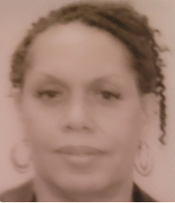 | Tonja Sutton Edwards  Experienced Professional
 | Seeking employment opportunities with exceptional technology driven organizations with vision for transforming company practices into cost effective solutions and efficient operations.
Experience  American Electric Power, Columbus, Ohio    August 2007 to July 2020  PROMOTED Business Service Coordinator: Fifteen years' of experience as a Business Analyst Application Administrator responsible for managing the operation of Legal Web Applications ensuring system operational stability, while participating in Project Planning assisting Project and Program Managers on strategic system related projects, collaborating with business stakeholders and cross functional teams for the development, documentation and delivery of process improvement innovations for the attainment and implementation of business goals, using agile methodology when analyzing business, user and technical requirements, prioritizing initiatives based upon business needs and the defined requirements.  - Accomplishments:  - Consistently captured and documented requirements BRD and analysis  - Successfully completion of User Acceptance Testing UAT with on time deliverables  - Identified and anticipate Risk and gap analysis documentation  - Identify, developed and provided KPI Metrics Dashboards including ad hoc data to help guide data driven decisions for executive leadership  - Successfully captured legacy data while strategically retiring legacy systems  - Provided cost saving metrics streamlining legal invoice processing by designing and implementing a staging table with stored procedures to receive and process electronic invoices  - Facilitate Change Management driving process improvements for adoption, acceptance and adherence  - Lead Monthly Staff Meeting for coaching and mentoring to staff  - Facilitate and lead instructional training workshops for guidance and coaching to management, staff, users and outside vendors on application functionality and business processes  - Develop training documentation and user guides consistent with standard procedures and best practices  May 2000 to August 2007  Legal Assistant: Experienced Paralegal assisting the General Counsel with managing complex litigation and legal department management. Responsible for performing legal research, gathering documents, capturing data, filing court documents and legal pleadings. Administratively managed attorney, scheduled meetings and conference calls, arranged travel, arranged trainings, special workshops, CLE's or charitable events. Responsible for preparing attorney expense reports, processed case management files, processed legal invoices and managed legal case management database. Draft and review legal documents and correspondence.  - Accomplishments:  - Promoted due to work performance and interpersonal facilitation  - Efficient Database Management of E-Discovery Documents  - Multi-tasking complex litigation matters while participating in Projects retiring legacy legal applications and identifying cost saving  - Subject Matter Expert  Experience    State Automobile Mutual Insurance Company  March 1983 to June 1989  Promoted Help Desk Specialist: Provided user support for test and production systems documenting user problems and resolutions. Provide technical support to user for system access, including telecommunication support. Created test cases. Ran batch jobs and reports. Liaison between user, business analyst and programmers. Delegated complex problems for resolution to programmers and analysts. Analyzed test projects, upon test completion, moved test project to production systems.  - Accomplishments:  - Efficiently documented system issue tickets for resolutions  - Supported End User PC issues  - Validated User issue was resolved  Education  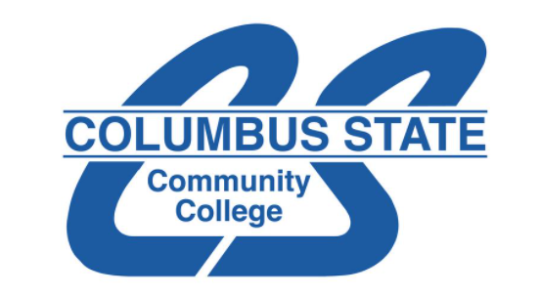  Business Curriculum  Columbus State Community College, Columbus, Ohio  - September 1981 to June 1982    Paralegal Certificate  American Institute For Paralegal Studies, Columbus Ohio  - September 1993 to June 1994  Professional Development Certificate  NetG Learning, Columbus, Ohio  - October 2005 | About Me  I am a passionate hardworking efficient forward thinking seasoned Corporate & Private Sector Legal Technology Professional with 20+ years’ diverse background in Technology, Legal, Insurance, Claims, Customer Service, and E-Commerce Retail, who enjoys tackling challenges and implementing solutions. Seeking opportunities to transform company practices into cost-effective solutions leading to efficient operations.  Contact Me  Email  edwardsut50@gmail.com  (614) 806-6585  http://linkedin.com/in/tonja-sutton-edwards-b5915717  Education  Certified Paralegal  American Institute for Paralegal Studies  Columbus, Ohio  Business Studies  Columbus State Community College  Columbus, Ohio  Professional Development  NetG Learning  Columbus, Ohio  COE Certificate/HS Diploma  Eastmoor High School  Columbus, Ohio  Skills  METHODOLOGY PROFICENCIES :  - Agile  PROGRAMMING PROFICENCIES :  HTML  DATABASE PROFICENCIES :  - Limited SQL  - Oracle  - Data Mapping  TOOLS PROFICENCIES :  - MS365 Product Suite  - SharePoint  - Access  - Excel  - Powerpoint  - Asana  SYSTEMS PROFICENCIES :  - PeopleSoft  - Business Objects  - Cognos  - ALM  - ServiceNow  - ARCS  - IManage  - Teamconnect  - Collaborati  - RSA Secur  - Outlook  - Lotus Notes

