|  |
| --- |
| University of new mexico |
| ECE 322L Final Report |
| Design Project |
|  |
| **Telmo Díez**  **Saul Macías**  **Francis Sala**  **Md Azam** |
| **24/04/2015** |

|  |
| --- |
| Spring 2015 |

Index

1. Introduction
2. Circuit diagram and frequency response of the circuit.
3. Simulation Results
4. Introduction

The aim of this project is to design amplifiers using FET and BJT technology for sound systems. In order to accomplish this goal this project has a series of requirements that we had to follow.

Requirements:

* Voltage Gain: Av = 50
* Input Impedance > 70 KΩ
* Output Impedance < 8Ω
* Available power supplies are voltage regulated +12V and –12V.
* fL=20Hz/ fH=20KHz
* Maximum Symmetrical Swing = At least +/- 1.2V (Extra credit for the team with the highest maximum symmetrical swing)
* Minimize power dissipation (extra credit for the team with the minimum power dissipation)

With these specifications we simulated our circuit in a computer program and then we built in a printer circuit board (PCB).

1. Circuit diagram and frequency response of the circuit.

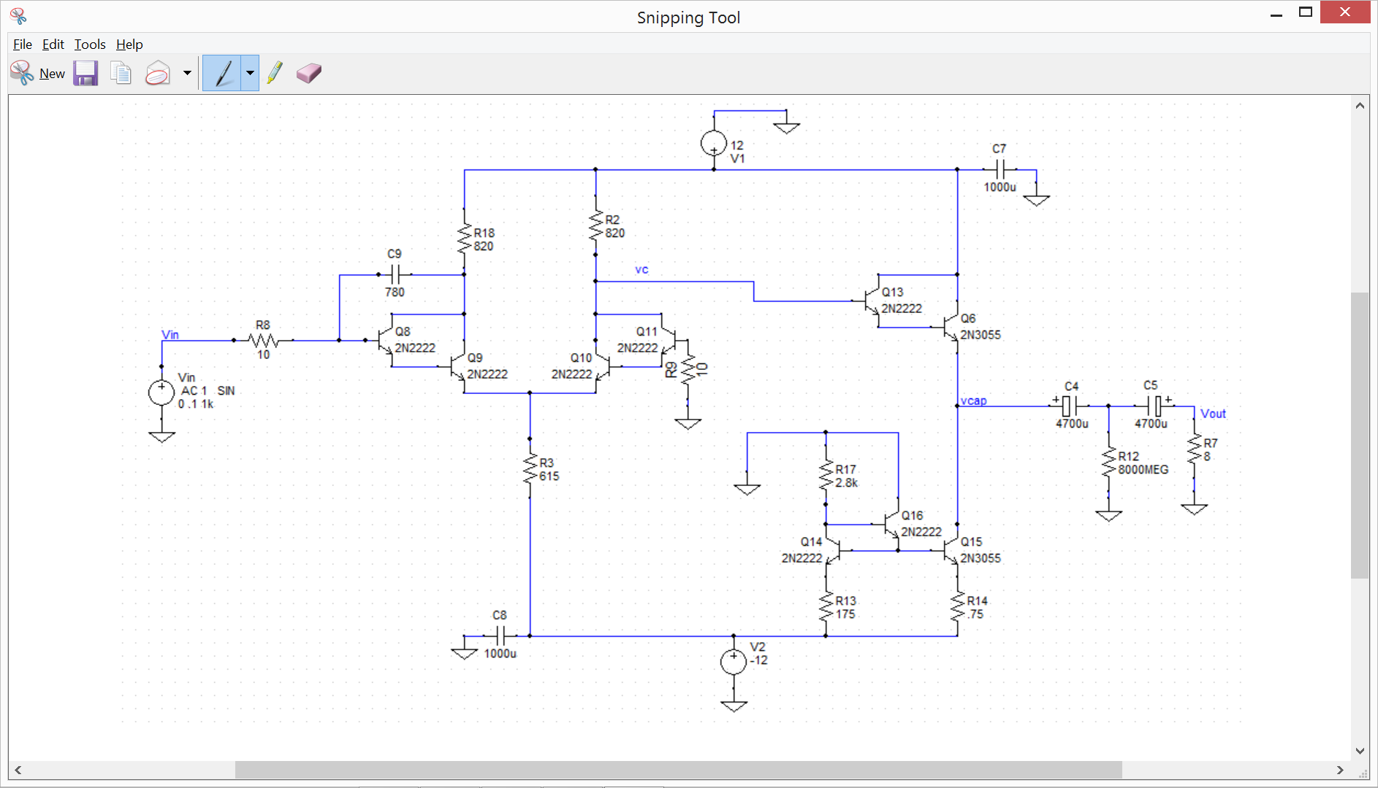

*Figure 1: Circuit Diagram*

Input: We chose the differential input stage because it has high input impedance; this helps us achieve our 70kΩ requirement. And this input also helps us to decrease the noise and have a more stable circuit.

Lots of op- amps like the LM741 use differential inputs. These are really stable chips, so we decided to use this stable input configuration for our setup.

Output Stage: We chose to use a Darlington configuration in order to produce a current gain for the output. Also we used a current mirror setup to bias the emitter current from the Darlington configuration. We biased the current on the collector of Q15 to be about 700mA. Our current mirror uses a Wilson setup. The purpose of this setup is to provide stability on the base currents for Q14 and Q15.

We put in two 600pF capacitors from the collector of Q8 to the base of Q8 in order to lower our frequency response fH. That’s we may observe that the further simulation results doesn’t match with the real practical simulation.

This is one example that simulation even if it can be very accurate and is helpful doesn0t always match with real life.

Component choices: We used the 2N3055 transistors in Q6 and Q15 because these transistors can handle large values of currents and voltage.

For R14 we used a power resistor that can handle up to 10 W. And we used the 2N222 because they are common transistors that we know how they work theoretically and that we have also used in previous lab sessions.

|  |  |
| --- | --- |
| Av | 55.5 |
| Rin | 242 kΩ |
| Ro | 430mΩ |
| Vpp | 3.46 V |
| fL | 36HZ |
| fH | 19.6KHz |
| Ps | 5.2 W |
| Pd | 5.5 W |

*Table 1: Practical Results*

AC Equivalent Circuit

DC Load Lines

AC Load Lines

1. Simulation Results

We used TopSpice for our simulation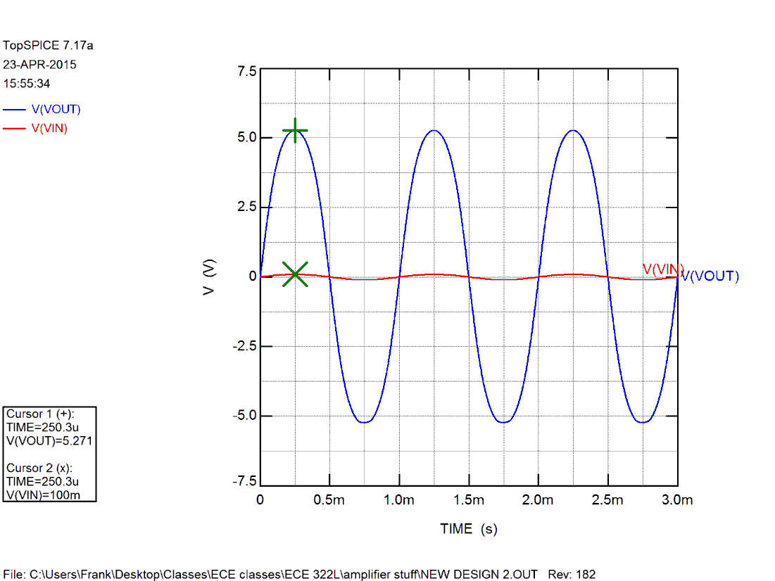

*Figure 2: TopSPICE simulation*

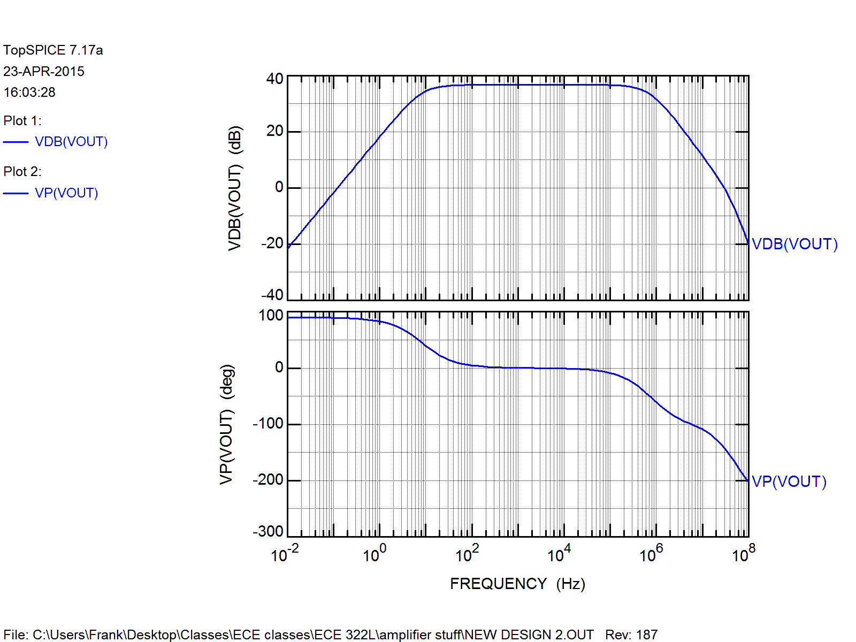

*Figure 3: AC simulation*