Republic Of cameroon

******

Peace-Work-Fatherland

******

ministry of agriculture and rural development

******

RURAL EQUIPMENT AND DEVELOPMENT SPECIALISATION TRAINING SCHOOL, KUMBA

******

republique du cameroun

*****

Paix-Travail-Patrie

******

MINISTERE DE L’AGRICULTURE ET DU DEVELOPPEMENT RURAL

******

ECOLE POUR LA FORMATION DES SPECIALISTES EN EQUIPEMENTS ET AMENAGEMENTS RURAUX, KUMBA

******



INTAKE AND DISTRIBUTION OF SPRING WATER AT DANY CASH QUARTER IN KUMBA III MUNICIPALITY

A project submitted in partial fulfillment for the diploma of Senior Technician in Infrastructure, Rural Equipment and Water Management (TSIERGE)

OPTION: Drinking Water Adjustments and Hydro-Agricultural Improvements (DWAHI)

Presented by: KAMENI TCHETCHOUM Donald

|  |
| --- |
| Supervisor |
| Mr. Charles T. NYONGO |
| Msc. Water management, Msc. Water Engineering |

Batch

2014-2016

**Dedication**

*To my late father* KAMENI TCHETCHOUM Roger*, my mother* MBIADA JACQUELINE*, my* *brothers and my sisters.*

*May this work testify the depth of my gratitude.*

**Acknowledgements**

I thank the Lord God Almighty for all the blessings and grace that He gives me every day of my life.

My gratitude goes to Mr. NYONGO Charles for his availability at all times to ensure the monitoring of this work, for his modesty and sense of understanding to face my problems, for the rigor he knew how to impose.

I thank the director of REDSTS Kumba, Mme. AMBANI Francine for all the efforts she puts in order to make her students work and study in good conditions.

I thank the teachers of REDSTS Kumba who guided me in research through education and support. I spare a kind thought for Mme. ANYERE Judith Arlette to whom I am very grateful for her availability and her advices she gave me in order to be able to go through this project.

To all my friends, I thank you, my brothers and sisters for your love and invaluable support.

To all whose names have not been mentioned here, but who have contributed in one way or the other to the success of this work, receive my sincere gratitude.

**List of Figures**

Figure 1: location plan of the site 1

Figure 2: Monthly rainfall and climate variations of Kumba 1

Figure 3: Measuring the flow rate using a stop watch and container 1

Figure 4: Measurement of flow rate using a weir 1

Figure 5: Simple development of a spring 1

Figure 6: Development of a spring with reservoir 1

Figure 7: Development of a spring with a reservoir and filter **Error! Bookmark not defined.**

Figure 8: Plan view of the spring box 1

Figure 9: Cross section A-A 1

Figure 10: Cross section A-A showing details of the spring box 1

Figure 11: Cross section B-B 1

Figure 12: Side view of the spring box 1

Figure 13: Spring during the rainy season 1

Figure 14: Spring during the dry season 1

**List of Tables**

Table i: Pollution and risks factors and reduction of risks 1

Table ii: Table of objectives and indicators of the analysis of water 1

Table iii: Table summarizing the demand of water in the community 1

Table iv: Estimate cost of the spring box 1

Table v: Table showing the estimated cost of the whole project 1

Table vi:Table showing quantity estimates of the spring 1

Table vii: Sample filling of the technical evaluation form of the spring box 1

Table viii: Sample filling of the durability and satisfaction of the project evaluation form 1

**List of Abbreviations**

ADB: African Development Bank

CPC: Centre Pasteur du Cameroun

DINEPA: National direction for Potable Water and Sanitation - Haiti

Dn: Nominal Diameter

GI: Galvanized Iron

ISSEA: Senior Institute of Statistics and Applied Economics

MINEE: Ministry of Water and Energy Resources Management

MDG: Millennium Development Goals

pH: Hydrogen Potential

PVC: Polyvinyl Chloride

REDSTS: Rural Equipment Development and Specialization Training School

WSSD: World Summit on Sustainable Development

**Abstract**

Like in every other institution, the end of training is marked by the students having to give out the best of their knowledge they were taught throughout their training by establishing a given project that can be executed. This is the case with this project which has as theme, “Intake and distribution of the spring water at Dany cash quarter in Kumba III municipality”.

After presenting the locality where the project is supposed to be executed, I gave the global objective of the project and the specific objectives of the project as a whole. Passing through a description of the theme by giving out some literature review on the development of springs, I continued by detailing the execution methods of the main structure which is the spring box. Thereafter, it follows the different results from site investigations and the site visits. After having collected the results, these results were analyzed and discussed thoroughly. It is under analysis and discussions that the hydraulic design of the structure is done and the descriptions of the spring box presented. Then followed the feasibility studies of the project which entailed the technical, financial and economic feasibility of the project without excluding the environmental impact activities. From the studies, the cost of the project as a whole has been estimated to **eight millions nine hundred and fifty thousand three hundred and thirty-four francs CFA (8,950,334 FCFA).**

**Key words:**

* Design
* Development
* Spring
* Spring box

**Résumé**

Comme toute autre institution de renom, une fin de formation est marquée par un projet de fin d’études qui est confié aux apprenants du domaine afin qu’ils puissent donner le meilleur d’eux-mêmes et mettre en œuvre tout ce qu’ils ont appris au cours de leur formation. Cela est le cas avec ce projet qui a pour thème « Aménagement et distribution à partir d’une source au quartier Dany cash dans l’arrondissement de Kumba III.

Après avoir présenté la localité où le projet se trouve, ce rapport présente les objectifs spécifiques et objectif global de ce projet dans son ensemble. Passant par la revue de littérature sur les différents aménagements de sources, puis j’ai donné un descriptif des activités qui rentrent dans l’exécution de l’ouvrage de captage. Ensuite nous avons les résultats des diagnostics faits durant les descentes sur le terrain durant lesquels certaines questions ont été posées aux habitants de la zone. Après cette collecte de données, elles ont étés analysés correctement. C’est sous cette analyse et discussion que nous retrouvons le dimensionnement hydraulique où il faut calculer le débit de la source et les diamètres des tuyaux à utiliser durant la mise en œuvre de l’ouvrage. S’en suit l’étude de faisabilité qui comprends la faisabilité technique, financière et économique, sans oublier les études d’impacts environnementales. De cette étude, nous avons estimé le coût du projet dans son ensemble à **neuf millions neuf cent cinquante mille trois cent trente-quatre francs CFA (8,950,334FCFA).**

**Mots clés :**

* Dimensionnement
* Aménagement
* Source
* Ouvrage de captage

**Table of Contents**

**Dedication** i

**Acknowledgements** i

**List of Figures** i

**List of Tables** i

**List of Abbreviations** i

**Abstract** i

**Résumé** i

**Table of Contents** i

**INTRODUCTION** 1

**Chapter 1: CONTEXT AND JUSTIFICATION OF THE PROJECT** 1

1.1. Context 1

1.2. Justification: 1

**Chapter 2: OBJECTIVES OF THE PROJECT** 1

2.1. Global objectives 1

2.2. Specific objectives 1

2.3. Expected results 1

**Chapter 3: LITERATURE REVIEW** 1

3.1. Choosing a spring 1

3.1.1. Site investigations and population diagnostic: 1

3.1.2. Quality of spring water and estimation of the resource 1

3.1.3. Flowrate measurements: 1

3.1.4. Types of resurgences 1

3.2. Development of springs 1

3.2.1. Techniques of development of springs 1

3.3. Pollution and risks factors: 1

3.4. Analysis of water 1

**Chapter 4: MATERIALS AND METHODS** 1

4.1. Materials and equipment 1

4.2. Execution methods 1

**Chapter 5: RESULTS** 1

5.1. The demand of water: 1

5.2. Analysis of water (chemical and microbiological analysis) 1

5.3. Management mechanism 1

5.3.1. Composition of the management committee 1

5.3.2. Management and maintenance system of the project 1

5.4. Site investigations results 1

**Chapter 6: ANALYSIS AND DISCUSSIONS** 1

6.1. Analysis and Discussions 1

6.1.1. Functioning of the structure 1

6.1.2. Temporal dam 1

6.1.3. Covering slab 1

6.1.4. Advantages and disadvantages of underground waters (springs) 1

6.1.5. Protection of the spring box 1

6.1.6. Protection of the area around the spring 1

**Chapter 7: FEASIBILITY STUDIES** 1

7.1. Technical feasibility 1

7.2. Financial feasibility 1

7.2.1. Quantity estimates 1

7.2.2. Estimate cost of the structure 1

7.2.3. Estimate cost of the whole project 1

7.3. Economic feasibility 1

7.4. Environmental impact studies 1

7.4.1. Negative impacts: 1

7.4.2. Positive impacts 1

7.4.3. Attenuation measures 1

7.5. Socio cultural feasibility 1

7.5.1. Social issues 1

**CONCLUSION** 1

**BIBLIOGRAPHY** 1

**ANNEXES** 1

**INTRODUCTION**

Of all the natural resources in the world, water features as the most indispensable. Forming part of economic and social rights, the right to water means that everyone without discrimination, must have access to water in sufficient quality and quantity to meet his/her basic needs. The provision of water should be sufficient, physically accessible and have an affordable cost, be clean and its quality acceptable for the personal and domestic use of everyone.

In Cameroon now more than ever before, the problem of water remains a necessity. This worry is constraint to successive years of dryness in some regions of the country and uncontrolled use by the population and also due to climatic changes. In order to think of a good water management and assure a good standard of living, Cameroon government puts in more efforts for the mobilization of its hydraulic potential although the mobilized resources are insufficient. This insufficient mobilization against the rising demand needs a more enlarged approach of the integrated management including all the actors concerned. This new approach will result in the optimization of water resources for development. Also, the development of countries passes through the protection of human health because without health, there is no development. Health comes through the consumption of water which should be potable in every aspect. In many developing countries, major cases of diseases and pathologies have their origin from water. Thus other methods for the supply of potable are foreseen which are; spring waters, wells, boreholes and surface water. Given that these sources of water are frequently used and are not correctly arranged, it will constitute potential infectious areas. Nowadays we frequently question ourselves on the accessibility of water. Its massive and wide use has made people take conscientious about the scarcity of water in many parts of the world and especially around the arid and semi-arid regions, the degradation of water resources and soils and its impacts on economic activities and also on the living conditions of the poor.

Presentation of the locality

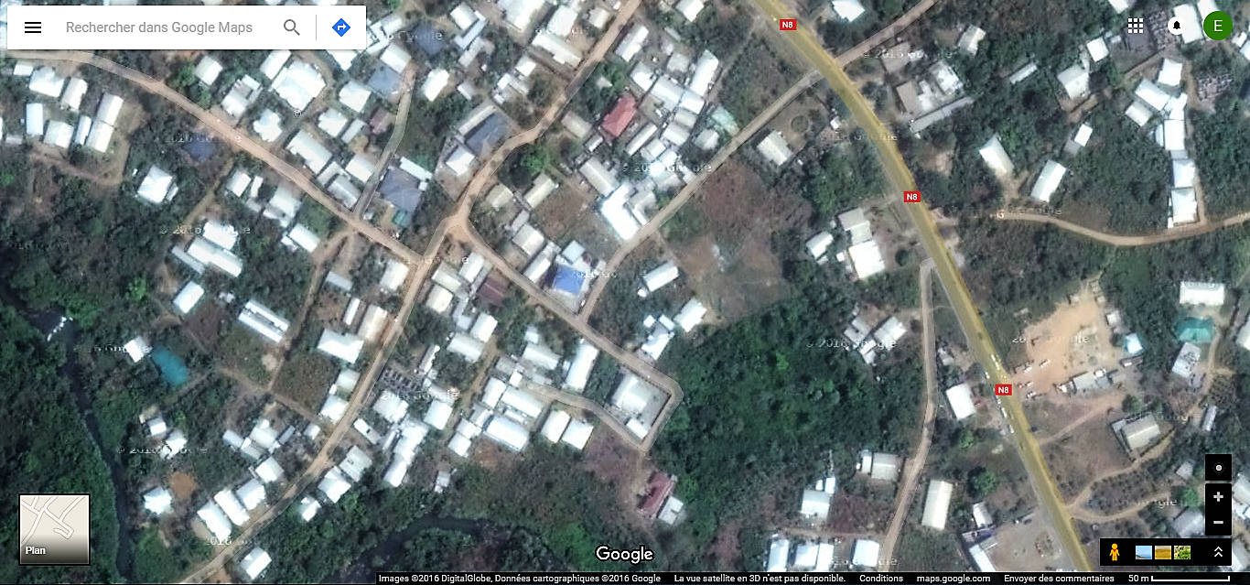The locality of Kumba where the project is situated is a large town surrounded by many villages. The highway roads N8 and N16 meet at Kumba. Found in the south west region, Kumba is a large developing town precisely located in the Meme division. The project is to be done at Dany cash quarter inside Kumba III municipality. The project site is not far from the main highway road N8 with geographical coordinates 4°48’N 9°27’E and elevation of 239m (790ft).

Figure 1: location plan of the site

1. Temperature: The annual temperature of Kumba varies between 22°C to 31°C and the average is at 26.5°C as shown on the graph that follows.
2. Rainfall: The maximum rainfall is recorded during the month of August with a value of 368mm and the minimal amount of rainfall recorded during the months of December and January. The total annual rainfall is 2751mm.

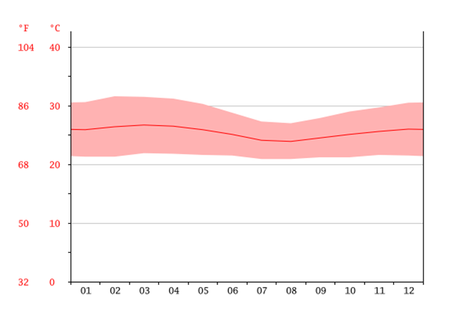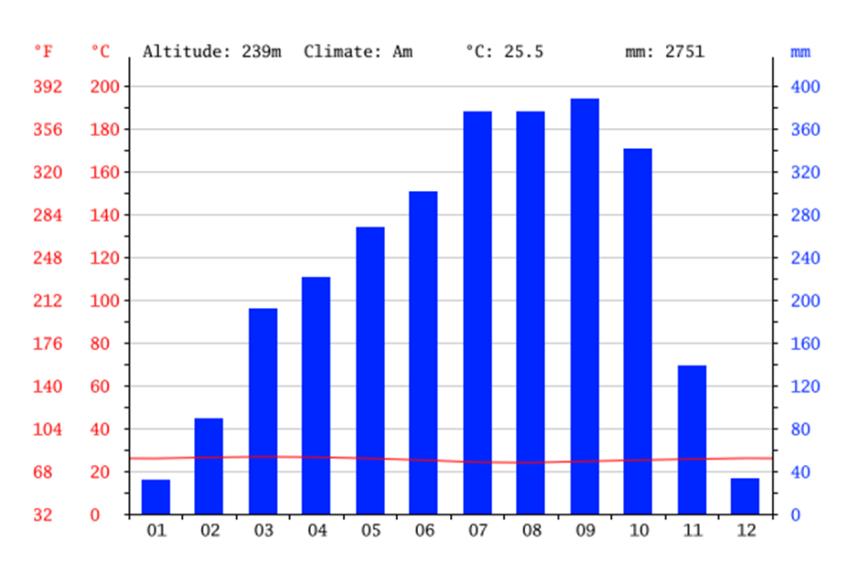

Figure 2: Monthly rainfall and climate variations of Kumba

1. Population: Kumba has an estimated population of about 4000 inhabitants while that of Dany cash is estimated to about 400 inhabitants.
2. Ethnicity: The indigenes of Kumba are the Bafaw speaking the Bafaw language but to migration, we find so many francophone around the area especially in Dany Cash quarter even though the Bafaws still form a greater of the population of the town globally.
3. Vegetation: The town is covered with a dense tropical vegetation, but due to recent urban developments, this vegetation is being wiped out seriously.
4. Socio-cultural development: The population of the quarter do not practice agriculture. They are mostly involved in business because about ¾ of the population falls in the youthful age group.

**Chapter 1: CONTEXT AND JUSTIFICATION OF THE PROJECT**

* 1. Context

Kumba is a big town situated in the south west region of Cameroon. It is made up of a large population having great differences in their standards of living. While in terms of development, the challenge is the same for everyone; have access to potable water. It should be noted that there already exists a water distribution network in the town managed by a private company with mixed management (public/private) but the water shortages occurring almost all the time make it difficult for the population in our project case, the population at Dany cash quarter. Added to the buying of bottles which is difficult for families with low (or no) revenues, the inhabitants carry water from other water sources and boreholes from the quarter or other surrounding quarters of the town which are not necessarily potable. One of these points is the borehole at Kumba Mbeng.

In the rural zones of Cameroon, we identify many springs but most of these springs are not developed thus exposing the populations to some water borne diseases. The ones which have been developed are either having a reservoir or are just arranged as a simple arranged. Treatment of the water can be done before distribution depending on the quality of the raw water. For the springs that have been developed, the factors that contribute mostly to the failure of the structures is the lack or absence of maintenance. Thus, it is the first factor to take into consideration when developing a spring. Its design should not only ensure an easy maintenance at very low cost but also, the follow up of the community in the maintenance of the structure to ensure its sustainability is very important. In the rural areas, fetching of water is generally attributed to children and women. Around the water source is usually present different activities such as bathing, laundry, washing of vehicles, etc. These users usually have a high confidence in their water resource but its maintenance and management is not that actually.

* 1. Justification:

After having spent two years at Rural Equipment Development and Specialization Training School (REDSTS) Kumba and having reached the end of the training, the students are given different proposed projects from different institutions in the South West region for them to design and establish. The projects were supposed to be studied, designed and established over a period of 2 months that is from March 9, 2016 to May 9, 2016.

With the goal which the Cameroonian has fixed which is the increase to access to good drinking water in urban and rural areas of the country, there is a need for all the exploitable water resources to be exploited in order to improve on the living standards of the population. This is why the Cameroonian government, through the MINEE, has to develop a project in the quarter Dany cash in Kumba III which has to deal with the development, supply and distribution of a spring water resource.

**Chapter 2: OBJECTIVES OF THE PROJECT**

The Millennium Development Goals (MDGs) were adopted by the international community in the year 2000 with access to safe water and sanitation as a key target of one of the eight goals. Similarly, most, if not all, of the other goals are directly related to water resources management. In order to achieve the Millennium Development Goals and implement the recommendations of the World Summit on Sustainable Development (WSSD) held in Johannesburg in 2002, the government of Cameroon decided to bring up the rate of access to potable water from 30% to 70% by the year 2035. The government foresees to create 22,000 equivalent water points and to rehabilitate 6000 equivalent water points by 2017 for water supply in rural areas.*(Sources: ADB, MINEE)*

* 1. Global objectives

This project is as a result of the Cameroonian government wanting to increase the access rate to potable water in the different urban and rural towns of the country. This project is to increase the access to potable water in Dany cash quarter.

* 1. Specific objectives
* To improve the access to water of a good quality and in sufficient quantities while respecting the conditions fixed by the country, by the realization of suitable infrastructures for the management of water resources;
* To organize the management of infrastructures by the creation of a management committee for the management of the resource and the training of its members in order to ensure a sustainable water service and also awareness-raising in the community of the Dany cash quarter on drinking water use, sanitation and hygiene;
* Reduce the rate of water borne diseases in Dany cash quarter.
  1. Expected results
* The average prevalence rate for diseases associated with the lack of safe water and sanitation (water-borne diseases) should decline by 20% in the community;
* Increased living standard of the community and creation of temporal jobs;

**Chapter 3: LITERATURE REVIEW**

A spring is a place where water comes out from the ground on its own. This water is usually good for drinking but it can be polluted. To avoid such cases, these springs have to be developed. Generally, springs are found in inland valleys and the hill sides. Springs can be permanent, meaning they do not dry up or are seasonal but its safety for drinking unless after analysis in a laboratory.

The development of a source is a set of techniques from the catchment to the distribution of water passing through an eventual storage. Development of a spring can also be making clean the immediate environment of a spring.

* 1. Choosing a spring

To choose a spring, the following steps should be taken into consideration. A spring usually occurs

* Where the impermeable layer reaches the surface;
* Where 2 layers of different compositions meet;
* When the upper layer meets the rock.

Nevertheless, the following aspects should be taken into consideration when developing a spring.

* + 1. Site investigations and population diagnostic:

A site investigation should be done before the development of a spring. During these investigations, the meetings with the community and the search of information through the afferent persons and organizations are crucial. A person living in the neighborhood of the spring is surely having a keen knowledge of the spring’s behavior for many years more than one who isn’t from around. The following questions are usually asked to the community.

* The usage of water: for drinking or equally for laundry, bath, etc.
* Which zone will be served and how many inhabitants?
* What are the other sources of water present around the area?
* The expected lifetime of the source

During the site visit we should confirm the collected information ourselves. In particular,

* The number of people coming to that water source;
* The type of emergence from the ground;
* Daily flowrate of the source in the dry season and in the rainy season;
* Quality of the raw water;
* Contamination risks of the source (presence of habitations, latrines, etc.);
* Landscape (can the source be distributed by gravity? Are there some high points?);
* Immediate land cover of the water shed (dense vegetation, rocks, easily erodible soil);
* Possible sources of pollution.
  + 1. Quality of spring water and estimation of the resource

Spring waters (underground water sources) are generally safe from pollution. The principal characteristics of underground water are presented below;

**Low turbidity:** This is because it benefits from natural filtration by the soil.

**Low bacterial contamination:** The long time spent by the water underground, the natural filtration and absence of organic matter don not favor the growth of bacteria.

**Constant temperature:** Ground water is protected from sun’s rays hence they have a constant temperature.

**Low color index:** Underground water is not in direct contact with vegetation which is the main source of color.

**Water hardness is elevated:** This is because underground water can be in contact with rocks which could contain group II cationic elements (Ca2+, Mg2+, …) of the periodic table which are responsible for hardness.

**High concentration of Manganese (Mn) and Iron (Fe):** These elements are usually found underground when the underground water does not contain dissolved oxygen.

The quality of water depends on the following factors:

* The thickness of the cover (vegetation) protecting the ground water, an important factor to avoid direct contaminations caused by latrines, fertilizers, etc.
* The permeability which influences the natural processes of infiltration
* The stocking capacity which influences the speed of infiltration. If the speed is too high, the pores are saturated and reduces the flowrate. This process is not common with volcanic and calcareous soils.

Since the flowrate and the quality of water depend on the same factors, we can have the following relation.

$$\frac{Flowrate during the rainy season }{flowrate during the dry season}=3 to 5 for good springs$$

The chosen springs should be studied during at least one year before they are being developed. It is preferable to make these measurements over a long time. Temperature changes during a day indicates that the source is uncertain because a good spring will present a constant temperature throughout the day.

* + 1. Flowrate measurements:

From the site investigations, we estimate the flowrates during low water levels (dry season) and during floods (rainy season). The flowrate during low water levels is compared to the water needs of the population and permits us to determine if the construction of a reservoir is necessary or not. The flood flow rate permits us to design the overflow. The measurement techniques of flow rates are given below

* **Stop watch with container (low flowrates):** To obtain a good accuracy, the time for filling the container should be taken between 30 to 60 seconds. The exact volume of the container should be noted before doing the measurement (bucket, drum, bottle, etc.). It is recommended to make many measurements and to retain the average value.

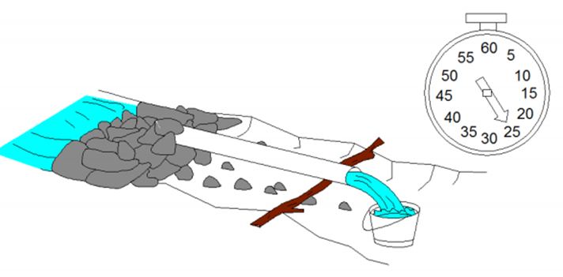

Figure 3: Measuring the flow rate using a stop watch and container

* **Floater and stop watch:** For a laminar flow, we can measure the section of the flux (surface of water perpendicular to the flow) then, with the help of the stop watch, the speed of the passage of the floater over a known distance. The floater should be dropped uphill of the measuring length in the middle of the canal. The velocity obtained is a surface speed generally higher than the average speed. We correct the calculation using a coefficient B such that

$$Q=B.V.S$$

Where:

Q= Flowrate (m3/s)

V=Speed (m/s)

S= Normal section of flux (m2)

B=Coefficient taken between 0.6 and 0.8

This method has a very low accuracy. The first measurement technique is preferable.

* **Measurement using a weir:** The measurement principle consists of placing a plank or a metallic plate perpendicularly to the direction of flow. The thickness of the water blade measured over this weir is proportional to the flowrate and depends on the characteristics of the device. The flux should be laminar and can be tranquilized by a sufficiently high sill (height of the spade). The thickness of the water blade should be measured at a distance from the sill less than or equal to 5 times the thickness of the blade of water.

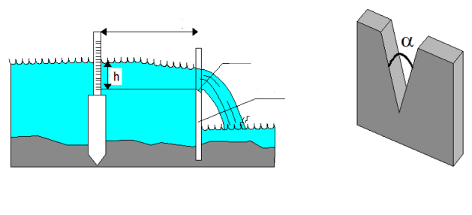

spade

Weir

Minimum 5xh

Figure 4: Measurement of flow rate using a weir

The shape of the weir is chosen as a function of the flowrate to be measured: the weir should help obtain a great variation of the height of water, for a small variation in flowrate. Mostly used shapes are triangles and rectangles of small thickness.

* + 1. Types of resurgences
    2. Fracture springs: These are springs that the emergence is as a result of the enlargement of a fracture in the soil by the roots of a tree. These springs can be artesian, their emerging zone is generally well seen and a spring box can be adopted.
    3. Water shed springs: Typical of basin regions, the water table is perpendicular to the landscape depression. The emergence of such sources are diffuse and drain catchment is adopted.
    4. Slope sources: It usually corresponds to the grouping of the piezometric level (unconfined water table) or the top (confined water table) with the landscape surface. The emerging zone of this type is usually diffuse except in the case of gullies

It is important to know the primary emergence of a source, which can sometimes be masked by some rock debris, swamps or an accidental landscape. The emerging zone can vary throughout the year.

* 1. Development of springs

Underground water can be polluted when being used or due to poor protection of the area where it is found. The proximity of latrines, watering place for animals, runoff water from rain un the sources, dust, the burying of wastes not far from the area can be the origin of the contamination of the ground water table. To avoid such cases, the springs have to be developed and well protected.

* + 1. Techniques of development of springs

The construction technique used is determined from the site visit. We generally proceed as thus;

* Cleaning of the emerging zone to clearly visualize the water outlets.
* Digging following the water outlets, while ensuring that the flow is not disturbed.
* Stop the digging once the impermeable surface is reached.
  + In case of a punctual source, it is advisable to place the spring box directly on the emergence (give an adaptive shape)
  + In case of a diffuse emergence, if it is not possible to collect everything by a drain, (different drains meeting in a deep collecting chamber located downhill of the source) it is preferable to do 2 spring boxes than to leave part of the spring not collected.

3 techniques of development of sources can be envisaged in a context needing low cost techniques.

* Simple development
* Development with a reservoir
* Development with a reservoir and filter
  + 1. Simple development

The place where underground water is coming out should be cleaned. Do a horizontal trench over several meters. Fill the trench with big stones so that water flows easily then recover the trench. At the extreme, seal a pipe by which water will flow out. The pipe (made out of PVC or GI) should be sealed in a wall made out of cement blocks or stones.

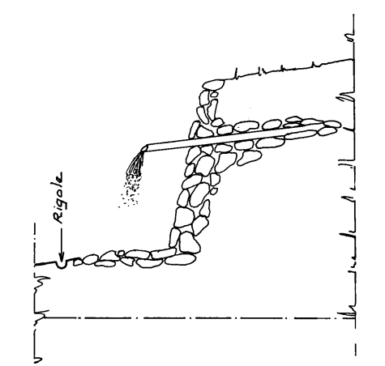

Ridge

Figure 5: Simple development of a spring

The ground where the pipe comes out should be levelled to avoid the formation of a bourbon. A plastic film covers the filter; it helps prevent rain water filled with impurities to mix itself with the spring water.

* + 1. Development with a reservoir and filter

This is made up of a chamber divided into 2 parts, one which contains a filter of sand and gravel and another part which constitutes the reservoir. The water pipe for the distribution is as in the other 2 previous developments.

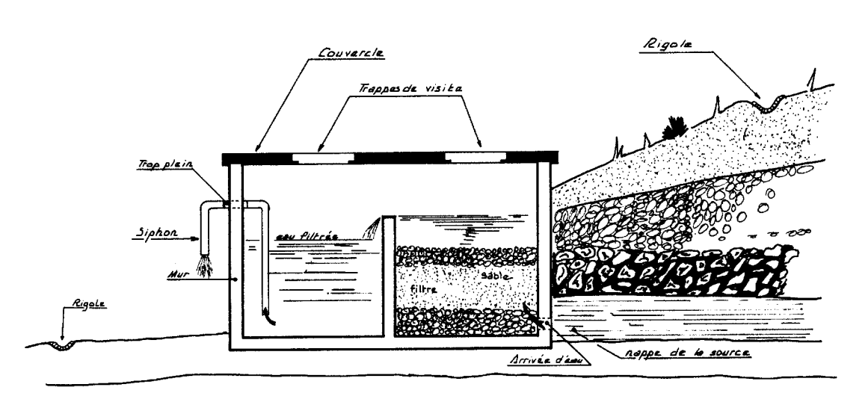

Figure 6: Development with reservoir and filter

* + 1. Development with a reservoir

We construct a masonry chamber which permits the collection and the storage of water from the source. The external arrangement is identical to that of the simple development.

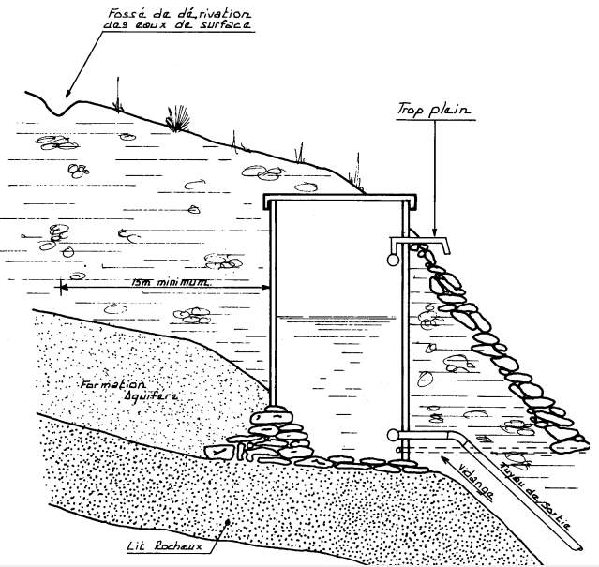

Figure 7: Development of a spring with reservoir

* 1. Pollution and risks factors:

The most common factors of population are the presence of population and animals around the spring.

Table i: Pollution and risks factors and reduction of risks

|  |  |  |
| --- | --- | --- |
| Risk factor | Reduction of the risk | Growth of the risk |
| Presence of residences | 100% of houses have latrines | Important seasonal variations of the flow rate |
| Presence of farms | Large fenced perimeter upstream |
| Presence of parks |

(Source: DINEPA)

* 1. Analysis of water

The table below summarizes the chemical, physical and chemical analysis of water according to the milieu where the water is found and according to the purpose (use) of the water.

Table ii: Table of objectives and indicators of the analysis of water

|  |  |
| --- | --- |
| **Objectives** | **Indicators** |
| Analysis before treatment (Filtration, chlorination, flocculation). | * Bacterial analysis * The demand of Chlorine * pH * Turbidity * Conductivity |
| Analysis after treatment. | * Bacterial analysis * Free residual chlorine * Aluminium * pH * Turbidity * Conductivity |
| Characterization of the « underground water » milieu. | * Conductivity * Temperature * pH * Cations (Ca2+, Mg2+, K+, Na2+) * Anions (Cl-, SO22-, NO22-, Alkalinity) * Trace elements traces (Fe, Mn, F…) |

**Chapter 4: MATERIALS AND METHODS**

The main materials and equipment to be used during the execution of the project will be discussed. A detailed description is given further on the execution methods of the project.

* 1. Materials and equipment
* Hydraulic excavator (with tires or with chains): principally used for excavations.
* Manual compactor: used for compacting all types of soils.
* Dump Truck: generally used for transport of gravels, soil and sand.
* Vibrating compactor type Bomag BW90: has as goal, to compact the earth in order to bring the porosity index of the turned earth to a closer index as that of non-excavated earth.

We also had other materials such as

* Concrete batch plant: Used to produce concrete following the prescribed formulation.
* Cement mixer: Used to mix the different components of concrete
* Autonomous shaker: Permits to reduce the proportion of gaps and remove air bubbles inside concrete.
* Formwork: Gives the form of the elements to be made out of concrete and reinforced concrete
* Shoring: Sustains the elements inside the formworks
* Motor pumps: Pumps water
  1. Execution methods
* Preparatory works:

It consists of cutting off the grass and clearing the zone. The area should be kept safe under security measures by putting security bands all around the working area.

* Excavations:

The excavation will be carried with a hydraulic excavator under the supervision of the topographical and geotechnical teams. It consists in the creation of a difference in altitude in order to correctly see the zones of resurgence of water.

* Temporal dam:

A small earth dike will be made, in which a temporal pipe is placed. The diameter of the pipe should be able to permit the distribution of all the flow rate of the spring. Its length is due to the topography of the place and should be able to distribute water during and after a working day. The temporal pipe should be ensured that it is well fixed because it is exposed to shakes during working hours and when the users fetch the water. Lastly, to leave enough space for the working, the earth dike should be constructed as close as possible to the emergence of the spring. The dike will have a length of 1m and a height of 50cm.

* Pipes:

The distribution pipe and the overfloware to be placed below the resurgence level no matter the flow rate of the emergence. This is done to avoid that the emergence should be in charge because when it is in charge, it will modify the flow rate of the spring. The distribution pipe will be cast into the blocking wall at a slope of about 5%. The suck away (drainage) pipe will be cast in the wall.

* Foundation:

After having realized the placement and after having well cleaned the substratum at the bottom, we dig a transversal trench in the downhill part in order to anchor well the foundation of the spring box. We put in the concrete (cleaning concrete + concrete) in the trench then we make the foundation go up to about 10 cm from the bottom of the box. All the foundations of structures which come into contact with ravines should be deep foundations (>50cm) so that water from the ravine should not scour from under.

* Drain screen:

We place the rocks while leaving spaces so that water from the emergence can flow through. We place every rock on mortar because it is best to increase the spacing in order to permit the maximum flow rate to pass but do not make spaces that are too large (<5cm) so that the earth should not fall more often in the spring box.

* Base slab:

It is advised to make reinforcements to avoid eventual cracks in the slab. A reinforcement with rods of 6mm and stirrups of 20cm is sufficient, the slab has to be cast on the cleaning concrete or on a layer of washed rocks. The base slab will be cast with concrete not containing much water. At the end it will have to be vibrated and plastering.

* Covering slab: The covering slabs are made out of reinforced concrete an is equipped with the visiting hatch. This visiting hatch can be either made of a metallic door or a removable concrete slab. For this project, we adopt the movable concrete slab because it is easy to set up and less costly and uttermost, it is very durable.
* Finishing touches:

The finishes touches are done by placing mortar on the inner and outer walls of the structures. When the mortar is dry, anti-corrosion paint will be applied accordingly on the inner walls of the spring box.

* Washing area

The washing area will be surrounded by a wall of about 20cm of height. The area should be downstream to the spring box.

* Hydraulic design

This mostly concerns the design of the distribution pipe and then choosing the corresponding commercial diameter that will ensure the distribution of water to the population.

* **Design of the distribution pipe:** The design of the of the distribution pipe is calculated based on the value of the flow rate. When the diameter is gotten, we deduce the corresponding diameter by using the formula that follows

$$D=\sqrt{\frac{4Q}{π*V}}$$

Where; D=Diameter (m)

Q=Flowrate (m3/s)

V=Speed of flow (m/s)

N.A:

Data: 0.32≤ V ≤ 0.8 because we are using PVC pipes; Filling rate= 6.39s for 1.5l

$Q=\frac{1.5}{5.39}$

Q=0.28l/s

* Q=0.00028m3/s

Thus diameter $D=\sqrt{\frac{4*0.00028}{π*0.4}}$

D = 0.02976m

***D≈30mm***

But we will choose a diameter ***D=32mm*** during the execution.

It should be noted that the delivery pipe should be caul and cast in the wall at a height of h/3 in an inclined position. That is exactly at 1.33m following the calculations below.

h’=h/3 where h=4

* h’=4/3

***h’=1.33m***

* **Design of the overflow pipe:** The overflow pipe is just above the delivery pipe and higher at 2h/3. On our structure, it will exactly be placed at 2.7m following the calculations below.

h’’=2h/3 where h=4

* h’’=(2*4)/3

***h’’=2.7m***

Here, we will choose a pipe of diameter ***D=63mm*** during the execution of the structure.

* **Design of the drainage pipe:** The drainage pipe is always placed at the lowest point, where the foundation just starts. It is advisable to choose a pipe of >2’’ for the drainage so that solid particles are easily evacuated. It is also recommended no to use more than one elbow of 90° and to place the drainage pipe at a slope of >3%. We will dimension the pipe so that it can evacuate the maximum flow rate of the source and this is to facilitate the cleaning of the spring box. With all these considerations taken into account, we will choose a drainage pipe of ***63mm*** and place it a slope of 3% on our spring box.

**Chapter 5: RESULTS**

The results here concern mostly the data collected on the field during the investigations and site visits. The following results were obtained during these investigations and site visits.

* 1. The demand of water:

Based on the durability of the materials to be used, the project has been evaluated to have a life span of 20 years. From the data collected on the field, the daily consumption (Vd) has been fixed at 55litres/day. The population growth rate has been evaluated to 3% (a=0.03). This value is also equal to the consumption growth rate. (b=0.03). *(Source: ISSEA, WHO)*

Table iii: Table summarizing the demand of water in the community

|  |  |  |  |
| --- | --- | --- | --- |
|  | Formula | Numerical applications (N.A) | Results |
| Present population (P0) |  | | 400 inhabitants |
| Present water consumption (C0) | C0=P0×Vd | C0=400×0.055 | 22 m3/day |
| Population after 20 years | P20=P0 (1+a)20 | P20=400(1+0.03)20 | 723 inhabitants |
| Consumption after 20 years | C20=C0 (1+b)20 | C20=22(1+0.03)20 | 39.73 m3/day |
| Volume consumed per day Vc | Vc=(C20×10)/24 | Vc=(39.73×10)/24 | 16.56 m3/day |

* 1. Analysis of water (chemical and microbiological analysis)

The sample of raw water taken on the site, on eye analysis, presented all the principal characteristics of underground waters which are low color index, no signs of turbidity, constant temperature, no odor and is apparently safe from chemical contamination. Even though it shows such good characteristics, another sample should be collected in a 250ml flask and sent to the reference laboratory Centre Pasteur du Cameroun (CPC) for a micro bacterial and chemical analysis. The hardness of the water should be checked alongside with the presence of elements such as Fe an Mn because these are also characteristics of underground waters with can be dangerous for health. The decision on the way to treat the spring water will be done upon the reception of the results of the analysis. Usually, the presence of fecal coliforms suggests a disinfection with hypo chloric solution. The pH should fall between the interval 5.5< pH <8 because we are dealing with underground water.

* 1. Management mechanism
     1. Composition of the management committee

Here it entails the sensitization of the beneficiary (Dany cash) population on the contamination risks factors of the spring and the protective measures. To do so, we can bring together and train a group of persons which will be specifically in charge of the good utilization of the resource. These can be constituted into a small local management committee composed of;

* A president of the committee
* A secretary
* A treasurer
* An accountant and could be more depending on the size of the community
  + 1. Management and maintenance system of the project

The management and maintenance of the structure will be ensured by the committee constituted of inhabitants who participated to the project and having followed training sessions on the functioning and maintenance of the structure in order to ensure the sustainability of the project.

If we want to have quality water and if we want that the water source should remain for long, it should be checked more often. The circulation of water and the evacuation drains have to be cleaned on a daily basis. All dirt around the area should be gathered and thrown away. The trench against run off water found above the spring uphill should be always clean and be ensured that the flow of water inside is undisturbed.

From time to time the spring box have to be cleaned. Using a chlorinated solution, the hands have to be cleaned before entering the spring box. One has to enter through the visit hatch into the spring box using a ladder after evacuating all the water from the spring box using the drainage pipe. The walls of the spring box have to be verified that they are still in a good state, if not they should be repaired. Brush the walls and the bottom of the spring box and spread all the walls of the structure with the chlorinated solution. Also, we have to check the accumulation of mud at the bottom of the spring box. Any amount of mud found have to be removed out of the spring box and the bottom cleaned accordingly.

The filter also has to be replaced at least every year. When the sand has already retained too much particles, it becomes clogged and the spring gives out less water, thus the filter has to be changed. We enter through the hatch and with the use of buckets, the successive layers of the filter are moved out of the spring box then replaced by new layers of sand and gravel. In the meantime, the walls of the filter section have to be checked if they are still in a good state, if not we repair the damages then we put back the new filter.

* 1. Site investigations results

It comprises of forms that have to be filled by an evaluator. The evaluator goes directly to the site where the structure is constructed and ask some questions to the population then fills the form according to the information collected. Sample questions asked during the investigations and future questions to be asked after the execution of the project are found in the tables at the annexes.

**Chapter 6: ANALYSIS AND DISCUSSIONS**

This chapter concerns mostly the analysis of the results obtained in the previous chapters. The design of the structure follows the results of the data collected on the field during the site investigations. Comments and discussions are provided further on the execution of the structure.

* 1. Analysis and Discussions
     1. Functioning of the structure

When water leaves the aquifer from the ground, it enters to the spring box by means of drains and small canals. The drain screen filters the water then the water enters first through the first section of the spring box and then rises by capillary action up to the summit. Through this rising process, the water is filtered a second time as it passes through successive layers of the filter (gravel, sand and stone). Once the water reaches the summit, it now overflows to the second compartment which acts like a reservoir. The water is able to flow through the distribution pipe continuously as the flow rate of the spring is permanent and varies only slightly. During periods of high rainfall, when the flow rate of the spring increases, the excess water from the spring box will be evacuated by the overflow pipe situated at a considerable height from the base of the spring box. The population can fetch water at the small box arranged just beside the spring box. The users can place their containers inside and wait for water to fill it. The water that flows continuously is sent to an exit by means of a drainage pipe.

* + 1. Temporal dam

This temporal dam serves to deviate water from the zone where the foundation will be done in order to sanitize the excavated area. This permits us to work on a drier place.

* + 1. Covering slab

The covering slabs are made out of reinforced concrete a contain the visiting hatch. This slab can be either made of a metallic door or a removable concrete slab. For our project, we are going to adopt the movable concrete slab because it is easy to set up and less costly, and uttermost, it is very durable.

* + 1. Advantages and disadvantages of underground waters (springs)

1. Advantages

- Investment costs and exploitation costs are lower and are dependent of the aquifer.

- The resource is extensive, facilitating the catchment on the site and minimizing the construction costs but needs many catchments in a case to satisfy a greater population.

- It is a natural resource needing no regulation. Less varying flow rate offering a resource more resistant than surface water, thus a more secured water supply.

- Some underground sources are totally safe from pollution. Others are vulnerable to pollution but not as in the case of surface waters and have to implement protective measures.

- It is possible to have a progressive equipment coping with the evolution of the demand.

1. Disadvantages

* Invisible resource, its precise evaluation needs the application of complex methods. Usually limited resource, not capable of, except in the case it does not supply a large town.
* The precise evaluations of the resource are costly.
  + 1. Protection of the spring box

The protection of the spring box consists of 2 parts;

1. The mechanical protection of the structure: We should be able to prevent the structures from risks upstream (earth retention, scree, mudslide, etc.) but also from risks downstream (gully erosion, land slide near the structure, etc.)
2. Protection of the spring from contaminations: This consists in avoiding runoff water from entering the spring box and to limit pollutions in the perimeter near the spring box.

The combinations listed up will help us fight against these 2 risks. Methods of protection is by establishing a protection wall and by constructing a drain uphill.

By using a protection wall, the spring box is protected so that the earth does not fall on the box nor cover its slab and also to maintain the part above the spring box clean. The placing of barbicans at the foot of the wall is indispensable to avoid a hydrostatic lift. The shape of the wall (in U or semi-circle) permits to resist the load of the soil.

By constructing a small drain uphill, the runoff water from rain will be drained away from the structure. The second method is the most commonly used and it is the method that will be implemented during the execution of the project.

* + 1. Protection of the area around the spring

Inside the fenced area, will be planted vegetation in order to avoid erosion. It should not have deep roots so that it should destroy the structures. Also, to deviate runoff water out of the catchment zone, the adequate solution is the combination to create canals. These canals should direct runoff water downstream and avoid erosions around the structures.

**Chapter 7: FEASIBILITY STUDIES**

In order to ensure the sustainability of the project, important studies should be made. The outcome of these studies tell us whether the project can be executed or not and whether it will be productive or not. The studies made to ensure the sustainability of this project are given below.

* 1. Technical feasibility

The project site is located downhill and since we have a spring of the aquifer type with capillary rises, the best method for its development is by using a spring box. Following the structural drawings which are presented at the annexes, the spring box is executed taking into consideration, the dimensions of these drawings. All the materials and equipment will be made available for the proper execution of the spring. The spring box is a rectangular shaped structure made out of reinforced concrete. The spring box has an overall height of 4m and is buried at a level of 1m. The outer walls of the spring box have a thickness of 0.15m while the separating wall has a thickness of 0.10m. The slab and base slabs have both the thickness of 0.1m. A small box will be created just adjacent to the spring box where all the containers will be placed for them to be filled with the water. This box will also act as a protection against issues of pollution and other issues such as the breaking of the distribution pipe. The spring box is divided into 2 parts. One part will serve as reservoir while the other part will be filled with sand and gravel which will act as a filter. The flow of the spring box will be continuous daily. 24h/24 and 7days/7 so no need to install valves.

* 1. Financial feasibility

This project is entirely financed by the state through the MINEE with main aim to improve the access to good drinking water by the population. Its financial goal will be financial equilibrium for those operating the facilities and infrastructure sustainability. The study made gave the following analysis that follow.

* + 1. Quantity estimates

In the table that follows, are presented the different volumes of the materials to be used in the calculation of the total cost for the execution of the project. These calculations are based on the results of the design and structural drawings that will be presented later in the work.

* + 1. Estimate cost of the structure

Following the different volumes of the materials that will be used in the execution, the volumes (quantities) are multiplied with the unit prices of the different materials (items). After having done all the calculations, the cost of execution of the spring box is estimated at 6,678,488FCFA.

Table iv: Estimate cost of the spring box

|  |  |  |  |  |  |
| --- | --- | --- | --- | --- | --- |
| **ESTIMATE COST OF THE SPRING BOX** | | | | | |
| **Cost for construction materials** | | | | | |
| **N°** | **Item** | **Units** | **Quantities** | **Unit Price** | **Total Price** |
| 1 | Reinforced concrete at350 kg/m3 | m3 | 17 | 107,000 | 1,819,000 |
| 2 | Mortar | m3 | 6.74 | 70,000 | 471,800 |
| 3 | Wood for shoring | m3 | 5 | 100,000 | 500,000 |
| 4 | Earth for backfilling | m3 | 2.5 | 6,000 | 15,000 |
| 5 | Gabions | m3 | 1.75 | 60,000 | 105,000 |
| 6 | PVC Dn 32 | lm | 0.5 | 2,000 | 1,000 |
| 7 | PVC Dn 63 | lm | 1 | 3,000 | 3,000 |
| 8 | Anti-corrosion paint | kg | 3 | 7,500 | 22,500 |
| 9 | Others (10%) |  | | | 72,188 |
|  | **TOTAL A** | | | | **3,009,488** |
| **Cost of labor** | | | | | |
| **N°** | **Category** | **Number** | **Daily salary** | **Paid days** | **Amount** |
| 10 | Controller of works | 1 | 10,000 | 5 | 50,000 |
| 11 | Foreman | 1 | 7,500 | 10 | 75,000 |
| 12 | Team head | 1 | 5,000 | 10 | 50,000 |
| 13 | Maneuvers | 6 | 3,000 | 10 | 180,000 |
| 14 | Specialized workers | 2 | 4,000 | 3 | 24,000 |
| 15 | Topographer | 1 | 4,000 | 2 | 8,000 |
| 16 | Geotechnician | 1 | 4,000 | 1 | 4,000 |
|  | **TOTAL B** | | | | **391,000** |
| **Cost of materials and engines** | | | | | |
| **N°** | **Item** | **Number** | **Daily rate** | **Paid days** | **Amount** |
| 17 | Hydraulic excavator | 1 | 350,000 | 2 | 700,000 |
| 18 | Vibrating compactor | 1 | 250,000 | 2 | 500,000 |
| 19 | Autonomous shaker | 1 | 150,000 | 2 | 300,000 |
| 20 | Cement mixer | 1 | 25,000 | 4 | 100,000 |
| 21 | Dump truck | 1 | 140,000 | 2 | 280,000 |
| 22 | Manual compactor | 1 | 60,000 | 3 | 180,000 |
| 23 | Pick up | 1 | 60,000 | 10 | 600,000 |
| 24 | Motor pump | 1 | 15,000 | 8 | 120,000 |
| 25 | PPI | 10 | 2,000 | 10 | 200,000 |
| 26 | Others (10%) |  | | | 298,000 |
|  | **TOTAL C** | | | | **3,278,000** |
|  | | | | | |
|  | **TOTAL COST A+B+C** | | | | **6,678,488** |

* + 1. Estimate cost of the whole project

The following table presents the detailed price for the whole work to be done during the execution of the project. It specifies the amounts, quantities and days of work of labor. It gives the final (real) cost of the project with the risks, price of labor and equipment to be used. The total real cost of the project is estimated at 8,950,334FCFA.

Table v: Table showing the estimated cost of the whole project

|  |  |  |  |  |
| --- | --- | --- | --- | --- |
| **ESTIMATE COST OF THE PROJECT** | | | | |
|  | | | | |
| **SPRING BOX** | | | | |
|  | | | | |
| **Daily output** | **Total quantity** | | **Units** | **Duration (Days)** |
| 0.10 | 1.00 | | Units | 10.0 |
|  | | | | |
| **Category** | **Number** | **Daily salary** | **Paid days** | **Amount** |
| Controller of works | 1 | 10,000 | 5 | 50,000 |
| Foreman | 1 | 7,500 | 10 | 75,000 |
| Team head | 1 | 5,000 | 10 | 50,000 |
| Maneuvers | 6 | 3,000 | 10 | 180,000 |
| Specialized workers | 2 | 4,000 | 3 | 24,000 |
| Geotechnician | 1 | 4,000 | 1 | 4,000 |
| Topographer | 1 | 4,000 | 2 | 8,000 |
| **TOTAL A** | | | | **391,000** |
| **Item** | **Number** | **Daily rate** | **Paid days** | **Amount** |
| Hydraulic excavator | 1 | 350,000 | 2 | 700,000 |
| Vibrating compactor | 1 | 250,000 | 2 | 500,000 |
| Autonomous shaker | 1 | 150,000 | 2 | 300,000 |
| Cement mixer | 1 | 25,000 | 4 | 100,000 |
| Dump truck | 1 | 140,000 | 2 | 280,000 |
| Manual compactor | 1 | 60,000 | 3 | 180,000 |
| Pick up | 1 | 60,000 | 10 | 600,000 |
| Motor pump | 1 | 15,000 | 8 | 120,000 |
| PPI | 10 | 2,000 | 10 | 200,000 |
| Others (10%) |  | | | 298,000 |
| **TOTAL B** | | | | **3,278,000** |
| **Item** | **Units** | **Unit price** | **Consumption** | **Amount** |
| Gravel | m3 | 12,000 | 60 | 720,000 |
| Sand | m3 | 10,000 | 45 | 450,000 |
| Cement | Sac | 8,500 | 84 | 714,000 |
| HA 08 | kg | 850 | 300 | 255,000 |
| RL 06 | kg | 250 | 215 | 53,750 |
| Gabions | m3 | 60,000 | 1.75 | 105,000 |
| PVC Dn 32 | ml | 2,000 | 0.5 | 1,000 |
| PVC Dn 63 | ml | 3,000 | 1 | 3,000 |
| Shoring | m3 | 150,000 | 3 | 450,000 |
| Anti-corrosion paint | kg | 7,500 | 2 | 15,000 |
| Earth for backfilling | m3 | 6,000 | 2.5 | 15,000 |
| Others (10%) |  | | | 276,675 |
| **TOTAL C** | | | | **3,058,425** |
| **TOTAL DIRECT COST (A+B+C)** | | | | **6,727,425** |
| General fees of construction site | | | **5.00%** | 336,371 |
| General fees for siege | | | **4.50%** | 302,734 |
| **REAL COST (D+E+F)** | | | | **7,366,530** |
| Risks + Profits | | | **21.50%** | 1,583,804 |
| **TOTAL REAL COST HTVA (G+H)** | | | | **8,950,334** |
|  | | | |  |
| **UNIT SELLING PRICE HTVA** | | | | **8,950,334** |

* 1. Economic feasibility

The project has many economic benefits. It will guarantee drinking water supply for the communities in Dany cash quarter and health; and ensure fairer distribution of benefits among economic agents (State, enterprises, sector operators, consumers). Considering the social nature of the project.

The economic returns are measured in terms of the benefits which accrue to beneficiaries in the form of regular and adequate drinking water supply, access to sanitation services, time gained, a decline in water-borne diseases and malaria and a general improvement in living conditions.

Quantifiable project benefits are represented by:

1. the economic value of the water produced;
2. savings on the health budget of beneficiaries owing to a decline in water-borne diseases;
3. savings on the education budget owing to a reduction in academic failure;
4. easing the strain involved in fetching water and the number of hours gained and put into more useful purposes.
   1. Environmental impact studies
      1. Negative impacts:
5. Impacts related to the choice of site:

The impacts linked to the implantations of infrastructures will be important if the sites chosen brings a restriction to the access of goods or the movement of the population.

1. Impacts due to the works

The works will bring some noise and the production of dusts for a limited time. During the execution of the structures, the terracing and levelling of the land will remove the vegetative cover, compacting the earth and the movement of earth, etc.

1. Impacts on the water source

The structures will distribute low quantities relative to the global resource of the water table. Also, the massive use of the structure can bring a localized pollution around the distribution zone.

1. Impacts on the vegetation

The impact on the vegetation will be low but nevertheless the vegetative cover will be removed during the site installation.

This indicates that there are few negative effects, mostly temporary and correctable through simple mitigative measures. These measures have been recommended to minimize the project’s negative impact on the environment in accordance with the 1996 Law on the Environment Code.

* + 1. Positive impacts

1. Impacts on the water source

The backfilling and excavations made will ameliorate the infiltration of water and facilitate the filling of the ground water table.

1. Impacts on the population

The setting in place and arrangement of the spring will increase the access rate to potable water hence increase the standard of living of the population.

* + 1. Attenuation measures

1. The execution of works

The executing enterprise is expected to take all the necessary measures in order to attenuate the impacts. The costs of these measures should be included in their international tender offer. The enterprise will also ensure that the norms of utilization of the site should be respected and that its cleaning and putting back in the appropriate state should be properly done.

1. Measures relative to the water source

As what concerns the water source, the project will activate a piezometric and physic-chemical (pH, conductivity) in order to evaluate the modifications of the ground water table and precise the seasonal variations of water.

1. Social measures

For the management of conflicts, the setting out of the project will be accompanied with actions aiming to encourage social cohesion between the communities, formations for the committee of water will be done in order to ensure the sustainability of the project.

* 1. Socio cultural feasibility
     1. Social issues

The project will increase sustainable access to drinking water for project area communities. Apart from providing sufficient water at close proximity (at most 500 m) to the inhabitants, the project will attach great importance to water quality and support the relevant technical services so that they can conduct, on a more regular basis, physic-chemical analysis of the water produced and distributed. The management committee will set the water rate and the money will later be used for future maintenance of the structures. Also, temporary jobs will be created for the youths present around the area. They will work in the project of their community.

# **CONCLUSION**

The study done for this execution project is very satisfactory and hence should be executed because it has a very low negative impact on the environment and the population and this low impact has been counteracted with attenuation measures. The Cameroonian government is in charge of all the water inside the different parts of the country. By all cost, the goal of the increase of access rate to potable water is the main objective of the Cameroonian government in terms of water policy. In order to ameliorate the living standards of its citizens, such types of projects have to be implemented all over the country. We focused our study mainly on the development of a spring from where the theme of our report, “Intake and distribution of spring water at Dany cash in Kumba III municipality. I recall that the problem is to capture all the resurgent water from the site into an adequate structure (spring box) and distribute it to the population. After having talked about the design of the main structure which is the spring box, a detailed presentation of its execution methods was done. The type of distribution chosen was according to the nature of the site. The direct distribution on the site was estimated to 8,950,334FCA which is rather cheaper as compared with distribution with a pump and reservoir.

In the end, this project is feasible in every aspects and will be of great helpto the population of Dany cash quarter.

**BIBLIOGRAPHY**

1. Action Contre La Faim. 2007, Eau-Hygiène-Assainissement pour les populations à risques, 2nd Edition. Ed. Hermann.
2. African Development Bank (ADB). May 2010, Project appraisal report-rural drinking water supply and sanitation project in South west region of Cameroon. Unedited.
3. Damien DuPortal, Le captage de sources, [www.interaide.org/pratiques](http://www.interaide.org/pratiques)
4. Denis ZOUNGRANA. June 2008, cours d’Approvisionnement en Eau Potable 2IE. 112p.
5. (DINEPA), Direction Nationale de l'Eau Potable et de l'Assainissement de Haiti. July 2012, Conception et réalisation des captages. 23p. Unedited.
6. Nathan W. REENTS, 2003. Design of potable water supply systems in Honduras. 50p. Unedited.
7. Patrice BOULLEYS. 2015, Lecture notes Water Supply and sanitation REDSTS. 176p. Unedited.
8. Thomas BONIERBALE. May 3, 2006, Etudes d'Impacts sur l'Environnement. Unedited.

**ANNEXES**

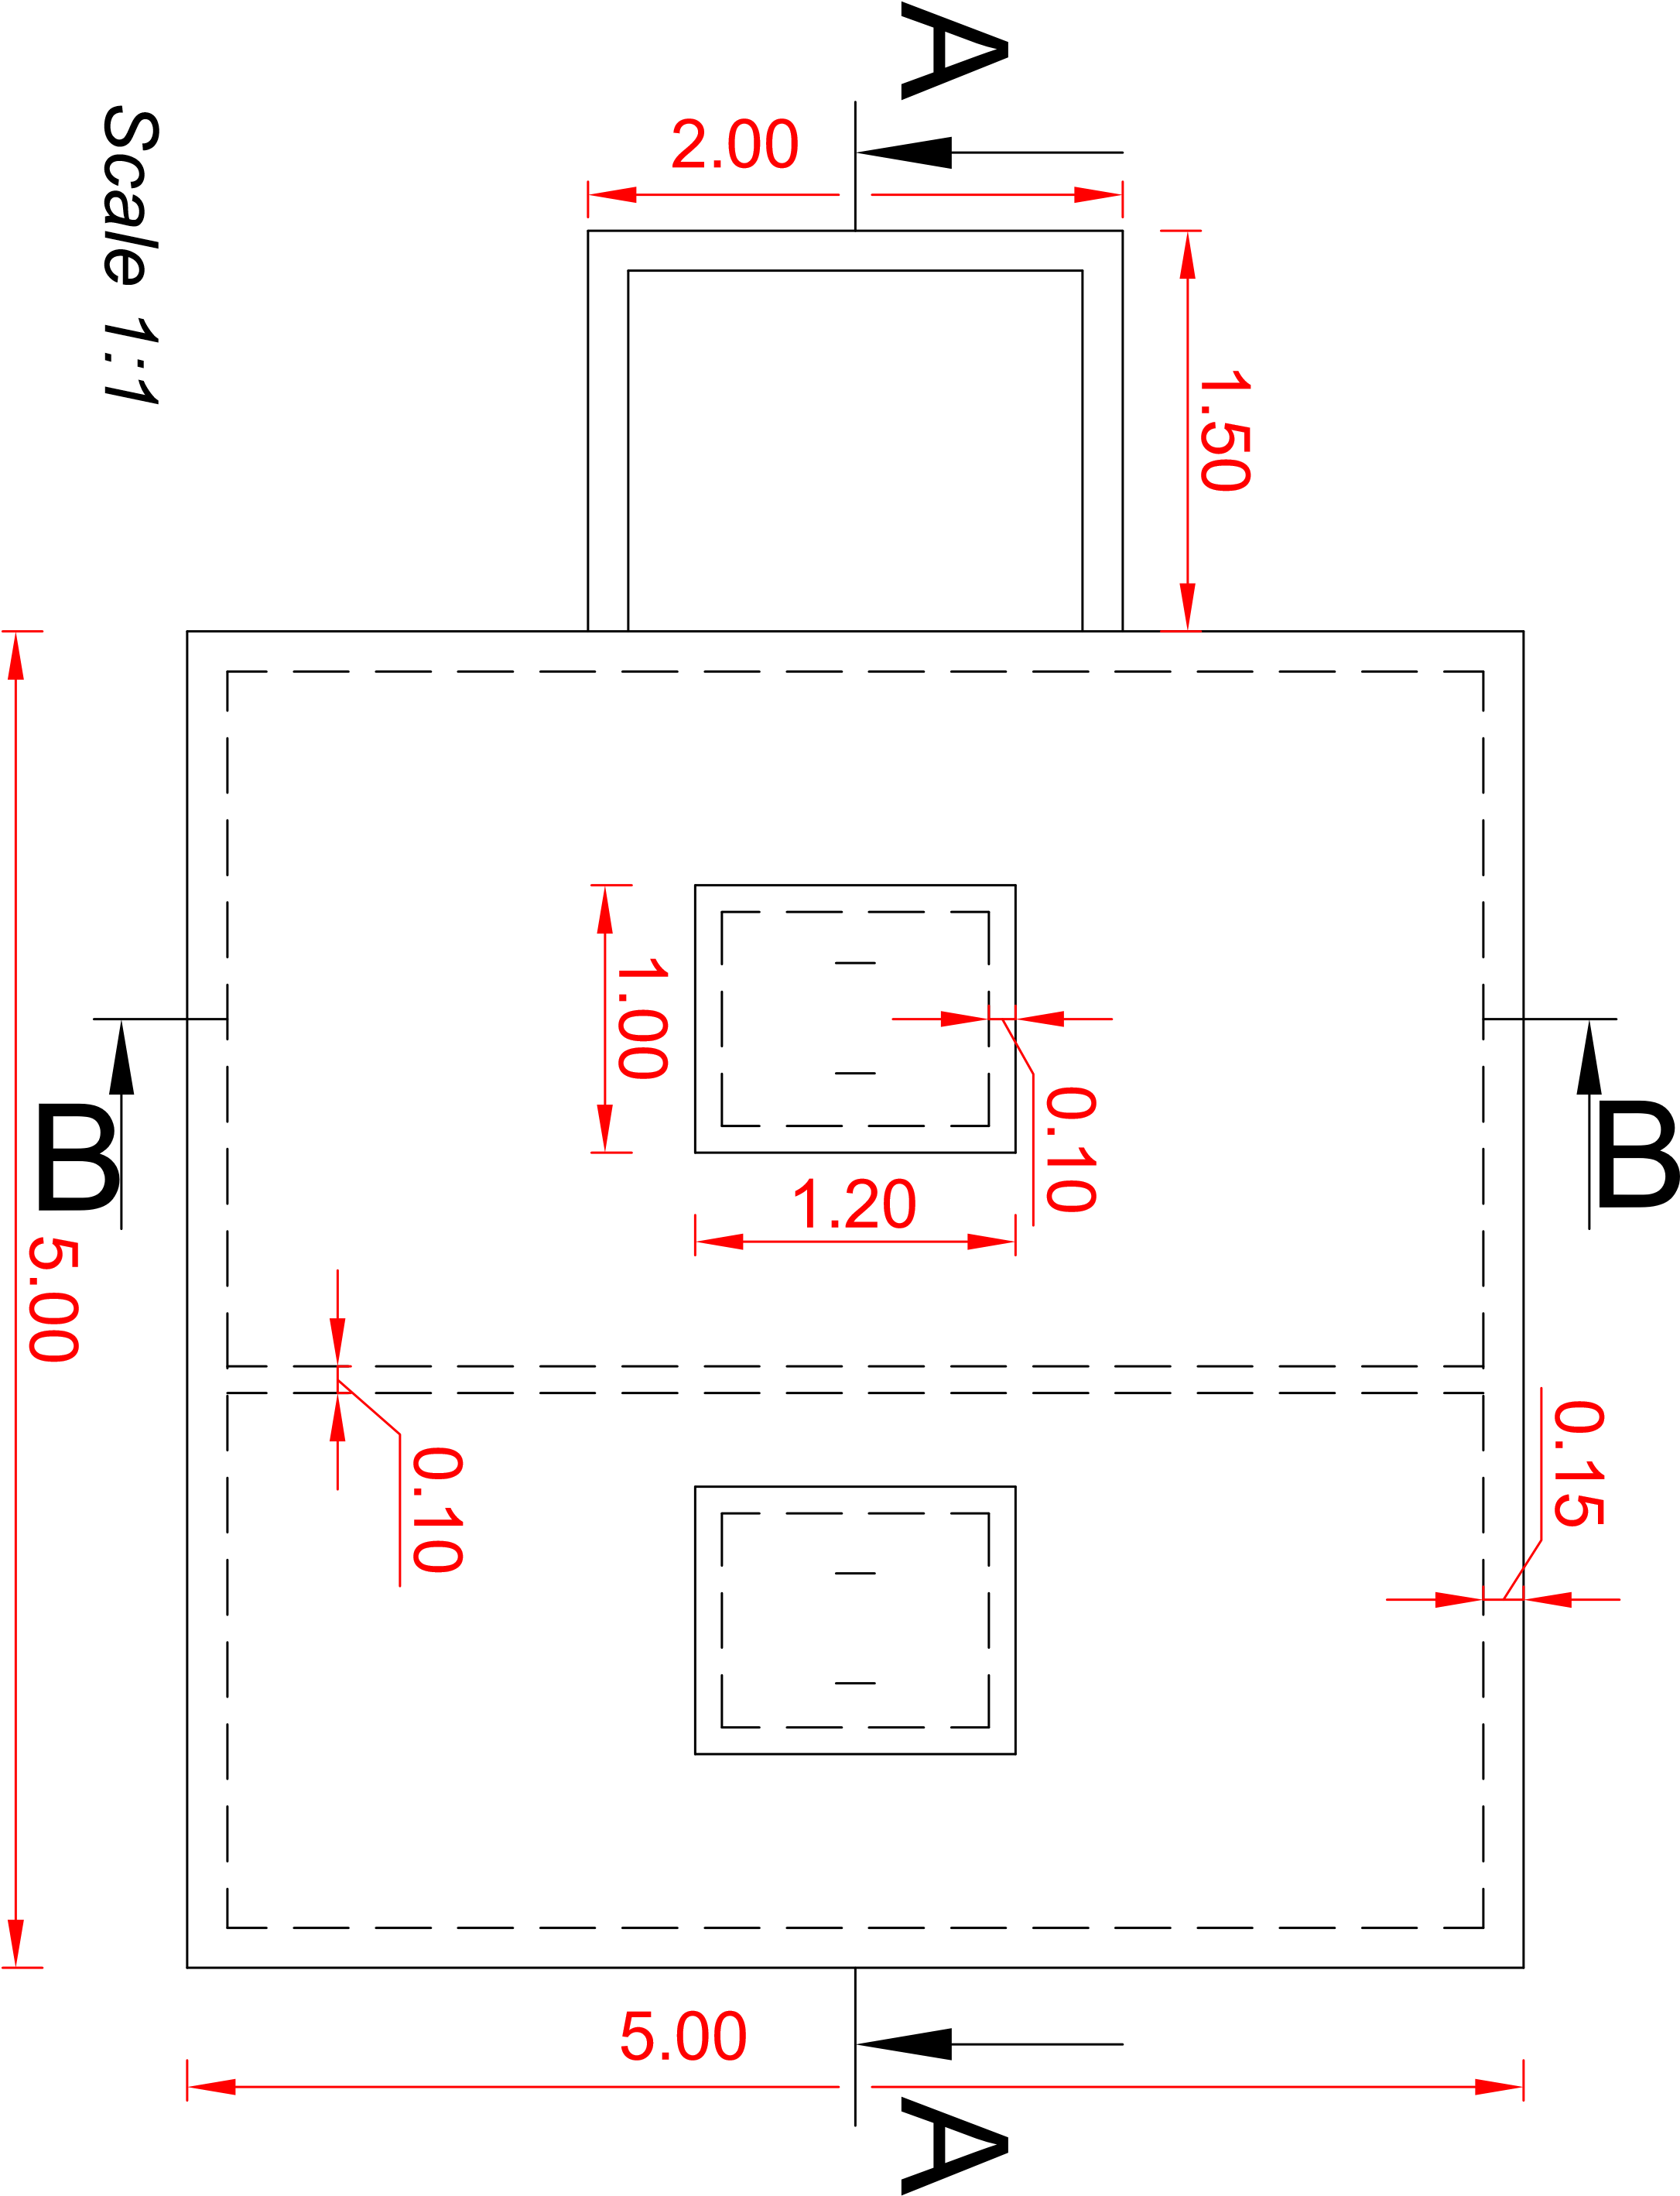

Figure 8: Plan view of the spring box

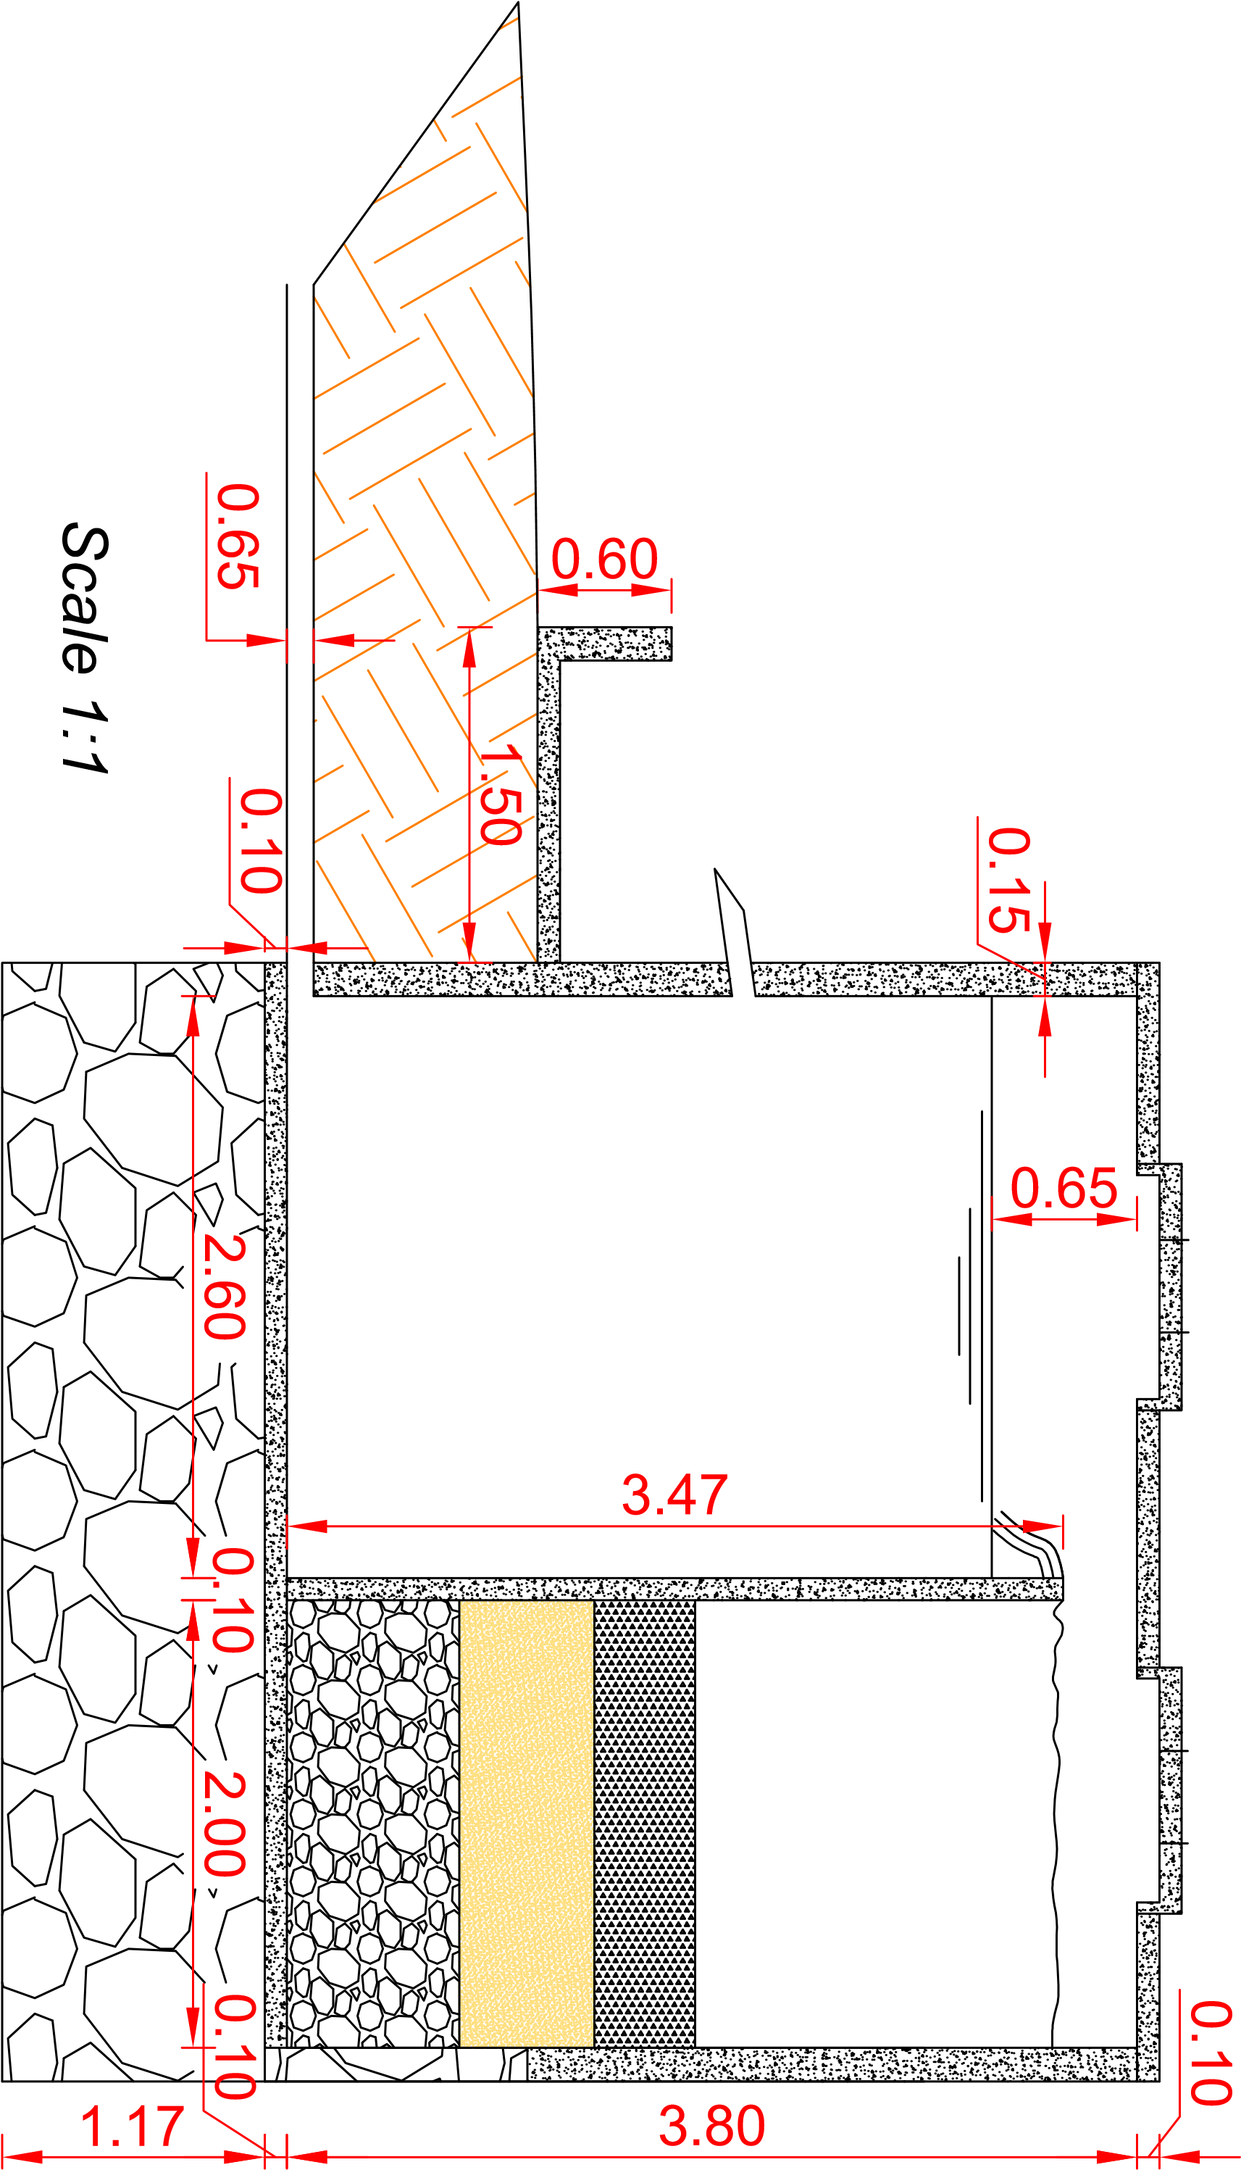

Figure 9: Cross section A-A

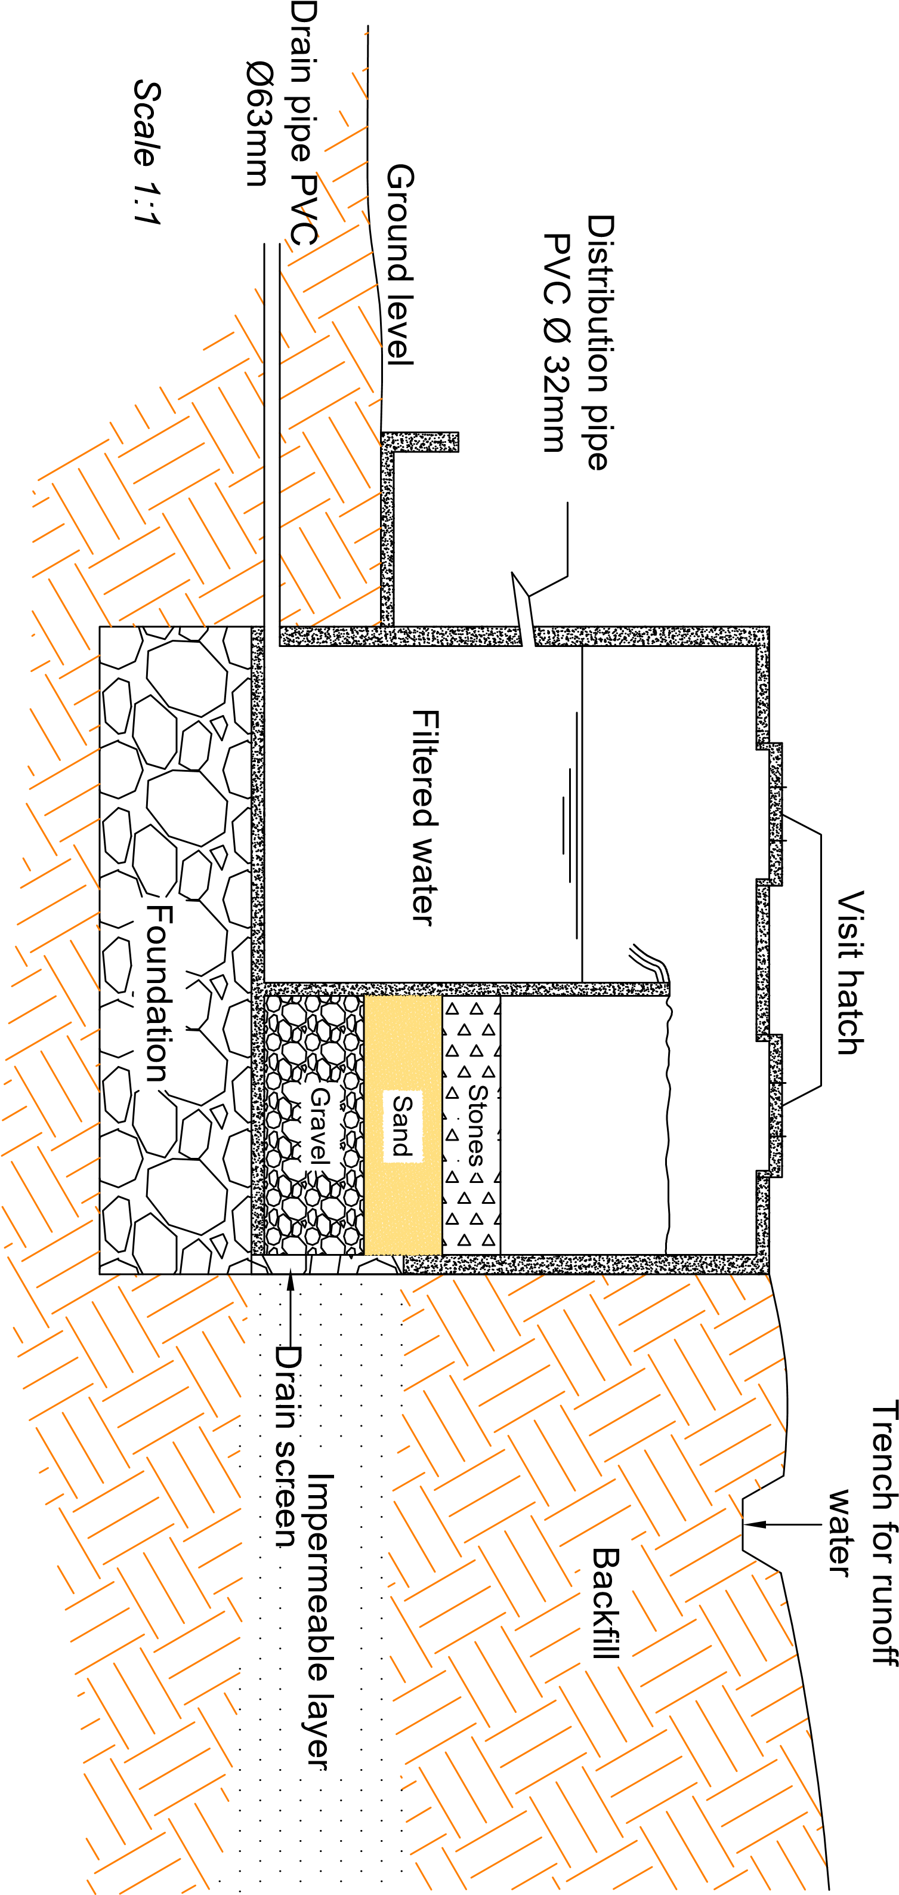

Figure 10: Cross section A-A showing details of the spring box

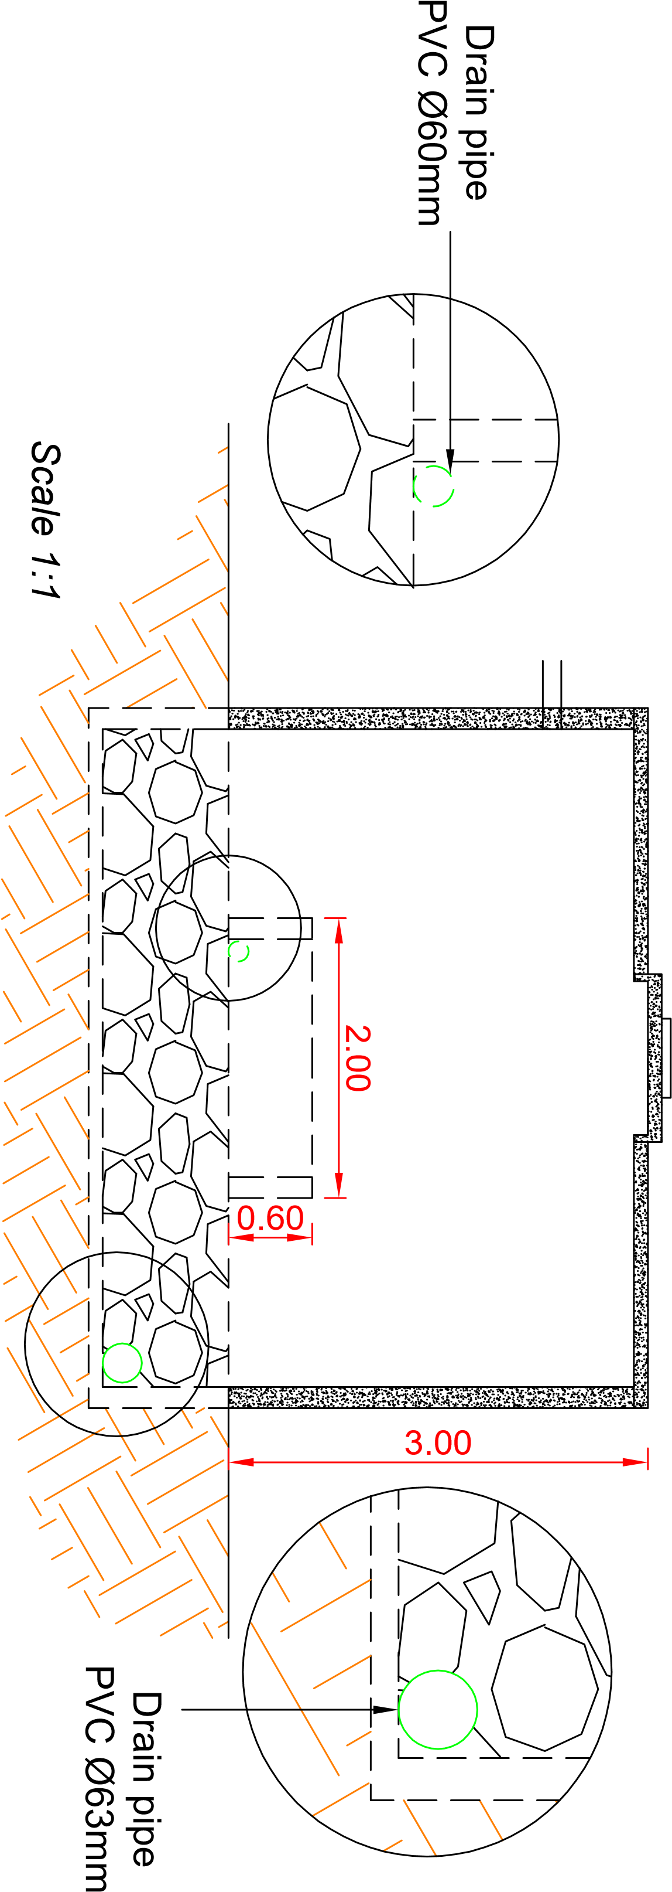

Figure 11: Cross section B-B

Overflow pipe PVC

Ø63mm

0.65

Scale 1:1

Ground level

Ground level

Figure 12: Side view of the spring box

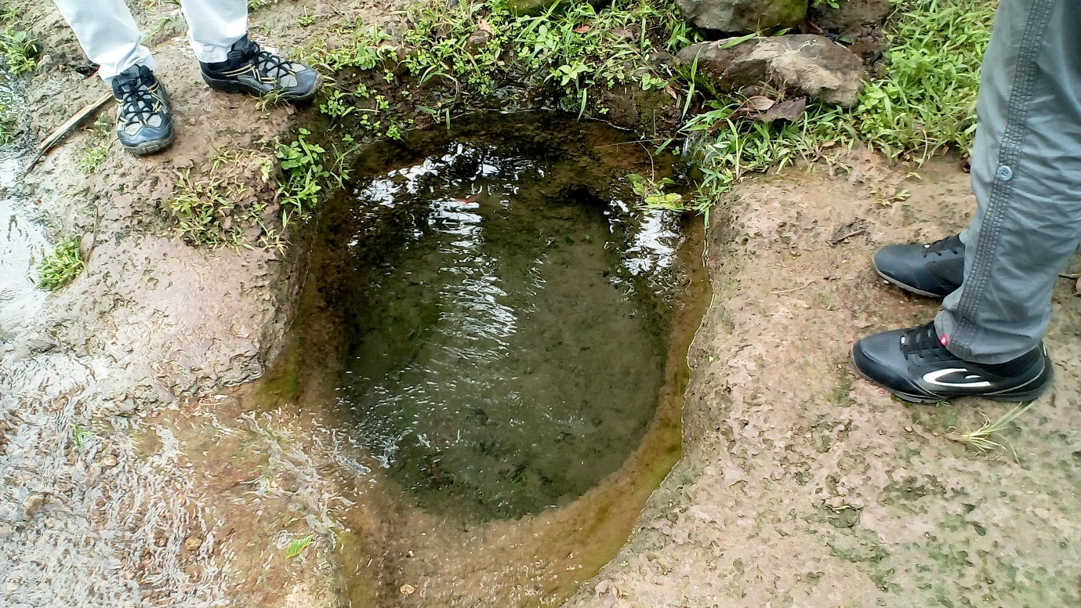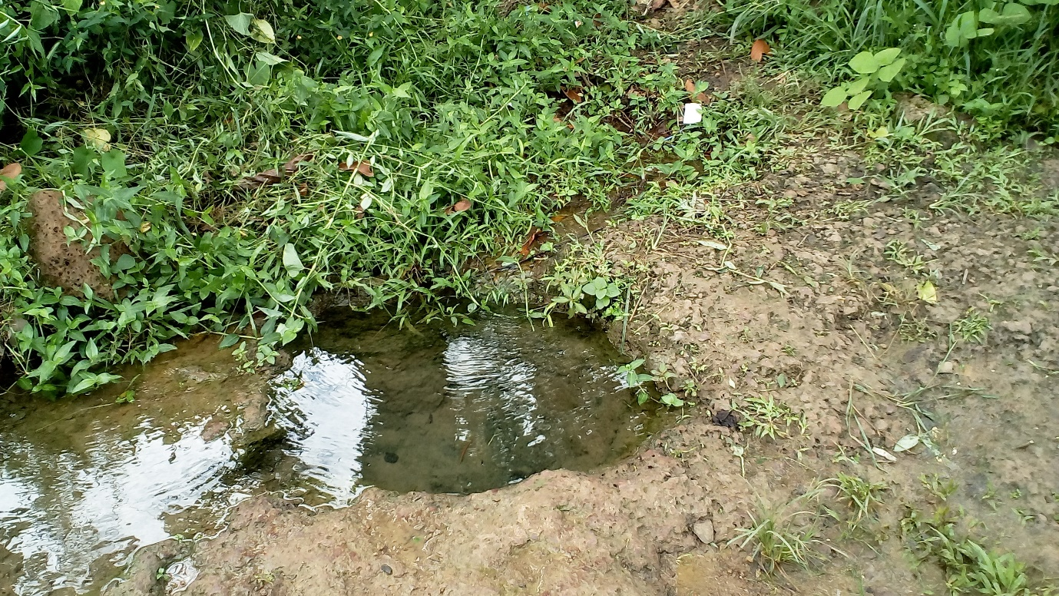

Figure 13: Spring during the rainy season

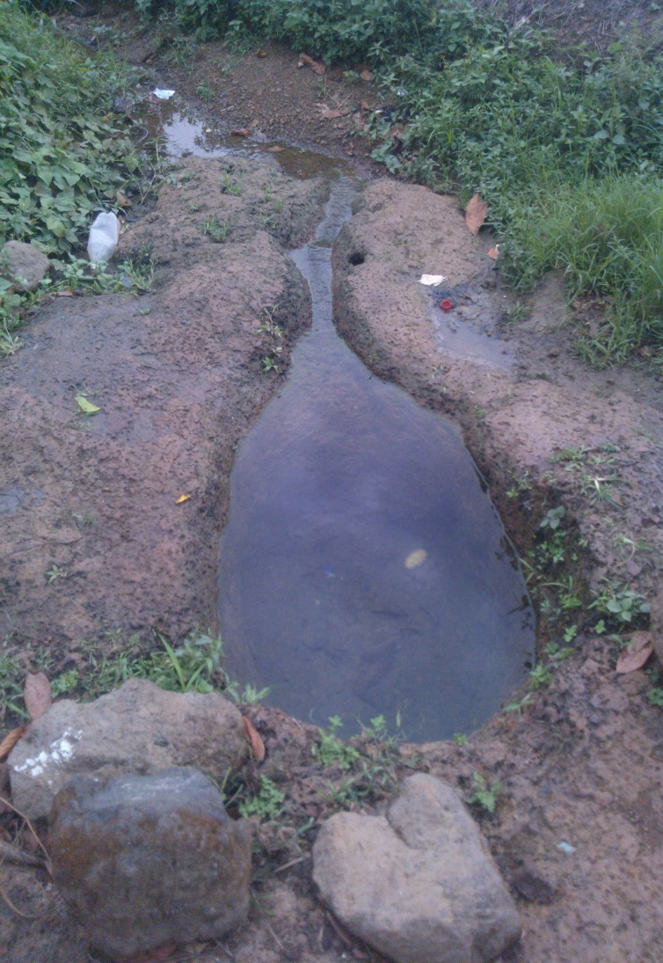

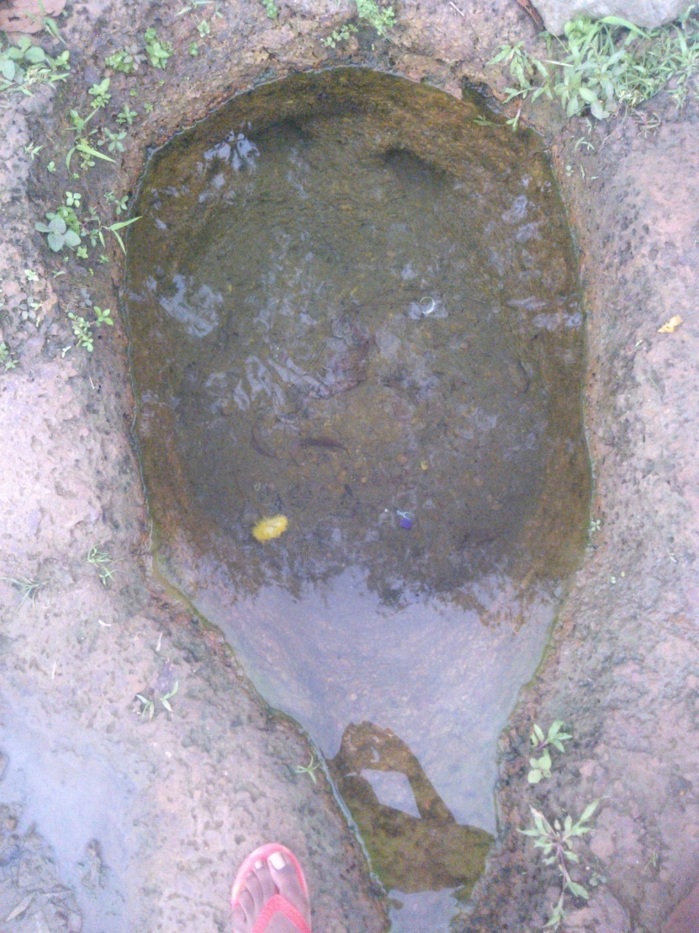

Figure 14: Spring during the dry season

Table vi:Table showing quantity estimates of the spring

|  |  |  |  |  |  |  |  |  |  |  |
| --- | --- | --- | --- | --- | --- | --- | --- | --- | --- | --- |
| **SPRING BOX** | | | | | | | | | | |
|
| **N°** | **Item** | **NSP** | **Quantities** | **Dimensions(m)** | | | **Surface (m²)** | | **Volume(m3)** | |
| **L/a** | **w/b** | **h/e** | **Partial** | **Total** | **Partial** | **Total** |
| **1** | Walls in reinforced concrete | 4 | 1 | 5 | 3.8 | 0.15 | 19 | 76 | 2.85 | 11.4 |
| **2** | Slab in reinforced concrete | 1 | 1 | 5 | 5 | 0.1 | 25 | 25 | 2.5 | 2.5 |
| **3** | Walls in RC of adjacent structure | 1 | 1 | 2 | 0.6 | 0.15 | 1.2 | 1.2 | 0.18 | 0.18 |
| **4** | Side walls of adjacent structure | 2 | 1 | 1.5 | 0.6 | 0.15 | 0.9 | 1.8 | 0.135 | 0.27 |
| **5** | Separating wall of spring box | 1 | 1 | 5 | 3.47 | 0.1 | 17.35 | 17.35 | 1.735 | 1.735 |
| **Total Reinforced Concrete** | | | | | | | | | | **16.085** |
| **6** | Cleaning concrete of spring box | 1 | 1 | 5 | 5 | 0.1 | 25 | 25 | 2.5 | 2.5 |
| **7** | Cleaning concrete of extension | 1 | 1 | 2 | 1.5 | 0.1 | 3 | 3 | 0.3 | 0.3 |
| **Total Cleaning concrete** | | | | | | | | | | **2.8** |
| **8** | Mortar for walls of spring box | 7 | 1 | 5 | 3.8 | 0.05 | 19 | 133 | 0.95 | 6.65 |
| **9** | Mortar of separating wall | 2 | 1 | 1.5 | 0.6 | 0.05 | 0.9 | 1.8 | 0.045 | 0.09 |
| **Total mortar** | | | | | | | | | | **6.74** |
| **10** | Gabions |  | | | | | | | | 1.75 |
| **Total gabions** | | | | | | | | | | **1.75** |
| **11** | Earth for backfilling |  | | | | | | | | 2.5 |
| **Total earth for backfilling** | | | | | | | | | | **2.5** |

Table vii: Sample filling of the technical evaluation form of the spring box

|  |  |  |  |  |  |  |  |  |  |  |  |  |  |  |
| --- | --- | --- | --- | --- | --- | --- | --- | --- | --- | --- | --- | --- | --- | --- |
| **TECHNICAL EVALUATION OF THE STRUCTURE** | | | | | | | | | | | | | | |
| N°: 001 | | Photos: Add photos if need be | | | | | | | | | | | | |
| Date: Mention the date when it is inaugurated | | | | | | | | Evaluator's name: Mr.… | | | | | | |
| **GENERAL INFORMATION** | | | | | | | | | | | | | | |
| Region: South-West | | | | | Quarter/Village: Dany Cash | | | | | Geographical coordinates | | | | X= 4.6080 |
| Division: Meme | | | | | Y= 9.4522 |
| Municipality: Kumba III | | | | |
| **SPRING BOX** | | | | | | | | | | | | | | |
| Type of arrangement: Spring box | | | | Arranged since (months) | | | | | | Organization/project promoter: MINEE | | | | |
| Not yet arranged | | | | | |
| Fabricant: Still to be known (not yet arranged) | | | | |
| Flow rate (l/s) | | Variation of flow rate according to seasons ? | | | | | | | | | Comments | | | |
| 0.28 | | Yes | | | | | No | | | | No comment | | | |
| Number of persons using the spring | | | | | | | | | | Is it delivering water accordingly? | | | | |
| 400 | | | | | | | | | | Yes | | | No | |
| Dimensions | L=5m | | W=5m | | | H=4m | | |  | | | | | |
| Comments | | | | | | | | | | | | | | |
| The walls have a thickness of 0.1m for internal walls and 0.15m for external walls. The slab has a thickness of 0.1m | | | | | | | | | | | | | | |
|
| **DAMAGES AND TECHNICAL REPAIRS** | | | | | | | | | | | | | | |
| What type of damage since installation ? | | | | | | | | | | Frequency | | | | |
|  | | | | | | | | | |  | | | | |
| Number of repairs | | Since 1 year : | | | | | | | | | | Delay time before repairs are done (days) | | |
|  | | Since date of execution : Cost of repairs: | | | | | | | | | |  | | |
| Comments | | | | | | | | | | | | | | |
|  | | | | | | | | | | | | | | |
|
|

Table viii: Sample filling of the durability and satisfaction of the project evaluation form

|  |  |  |  |  |  |  |  |
| --- | --- | --- | --- | --- | --- | --- | --- |
| **EVALUATION OF THE DURABILITY AND SATISFACTION OF THE PROJECT** | | | | | | | |
| N° | Date | Evaluator | Region | Division | Sub-division | Quarter |  |
| 1 |  |  | SW | Meme | Kumba | Dany Cash |  |
| THEME | | ELEMENT | | | NOTES | | |
| Setting in place of the project | | a) Participation | | | State (MINEE) and population | | |
| b) Financial contributions | | | MINEE | | |
| Institutional organization | | a)Management system | | | The Population manages the projects and derives entire satisfaction | | |
| b) Training | | | Training have been given to some people who serve in the maintenance | | |
| c) Important problems | | | The community know they have to solve the problem immediately | | |
| The supply of water | | a) The use of water | | | Used for drinking and cooking depending on the individual | | |
| b) The quality of water | | | The population thinks it is good for drinking | | |
| c) Viability of the water source | | | The flow rate is always satisfactory according to the needs of the users | | |
| The maintenance | | a) Technical know-how | | | Some technical know-how is available in the community | | |
| b) The equipment/tools | | | The equipment and tools are available for a rapid intervention in case of repair | | |
| c) Preventive maintenance | | | Done periodically | | |
| d) Finance for the maintenance | | | Population through some contributions | | |
| The community and social aspects | | a) access | | | Everybody in the community has access to the water | | |
| b) Impact | | | Positive | | |
| c) Satisfaction of the users | | | Greatly satisfied | | |
| d) Sanitation sensitization | | | Sensitized by management committee | | |
| **SATISFACTION** | | | | | | | |
| Are the users satisfied ? | | | | | | Yes | No |
| Why ? | | | | | | | |
| The flow rate corresponds to the needs of the population | | | | | | | |
| Does the water have a smell ? | | | | | | Yes | No |
| Does it have a taste ? | | | | | | Yes | No |
| Is it having a turbidity ? | | | | | | Yes | No |
| Is it acceptable for drinking ? | | | | | | Yes | No |
| Does the quality of water vary according to seasons ? | | | | | | Yes | No |
| Does the quantity of water vary according to seasons? | | | | | | Yes | No |
| Is the quantity sufficient for everybody? | | | | | | Yes | No |
| What is the water used for ? | | | | | | | |
| Principally used for drinking and cooking | | | | | | | |
| What type of water source were they using before? | | | | | | | |
| Natural Spring water and domestic water from the CDE | | | | | | | |
| Which water source do the population prefer ? | | | | | | Old | New |