

**Loïc MASSE**

6 bis rue Louis Pasteur

92100 Boulogne Billancourt Cedex

FRANCE

Phone : +331 41 12 27 45

Mail : lmasse@meilleurmobile.com

Boulogne Billancourt 15th Septembre 2010

***Subject : Reference letter***

Dear Sir/Madam,

Mister Alban RUELLE practiced within our company Meilleurmobile, the position of assisting product manager as trainee from February 15th, 2010 till September 10th, 2010.

Within the framework of this function, Mister Alban RUELLE was brought in to carry out the following missions:

- On-line publishing~~)~~ of products (telephones, accessory, package)

- Merchandising of the sales of telephone with subscription (benchmark of the prices analysis, price policy, followed by sales, followed by the margin)

- Sales promotion (management of newsletters, managements of the emphases of product)

Over the course of his missions, Mister Alban RUELLE showed many skills and efficiency in his work and largely satisfied us.

Mister RUELLE Alban has always been a reliable and responsible person, both in his work and in his relationship with his colleagues. He moreover showed a very deep interest in marketing issues, especially on-line marketing. We thus wished to thank him for his curiosity as well as implication in the daily work.

That is why we strongly recommend the services of Alban. We are convinced that he can be a considerable asset in your company. I hope that his application can be considered and trust that he will answer your expectations.

I remaining at your disposal should you require further information,

Best Regards,

Mathieu Drida Loïc Massé

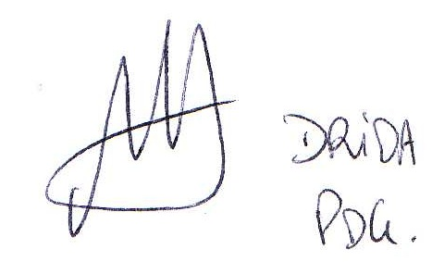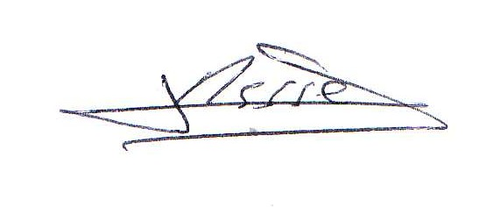Chairman and Chief executive officer Charge of e-commerce